GOVERNOR’S SECRETARIAT
ARUNACHAL PRADESH
ITANAGAR

Press Communiqué
Dated Apr 26th, 2025

Massive Forest Fire in Dirang Sub-Division
Brought Under Control
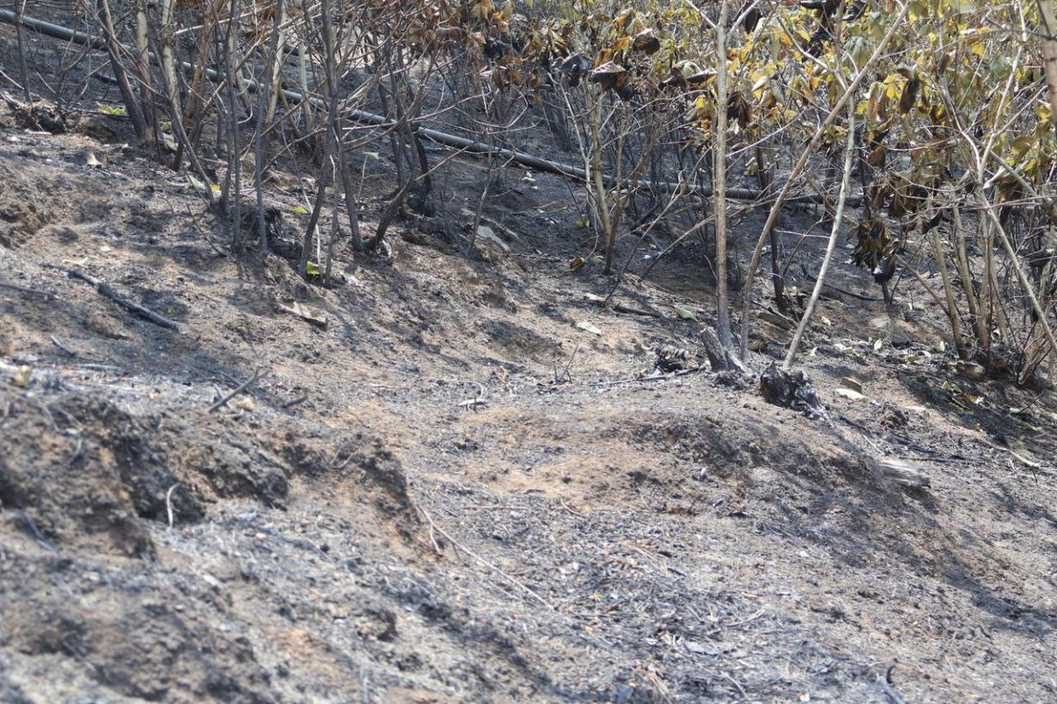

Dirang, 26th April: A massive forest fire that broke out in the Nadi Par area of Dirang Sub-Division, West Kameng district, on Thursday afternoon has been brought under control.
The fire reportedly originated from a short circuit approximately 50 meters away from the ADC Office in Dirang at around 2:30 PM. It rapidly escalated due to strong winds, dry grasses, and favourable forest conditions. Within just half an hour, the flames had spread rapidly, engulfing the surrounding forest area.
After continuous efforts over two days by the District Administration, ITBP, SSB, SDRF, Dirang Police, Indian Army, Fire Brigade, and local residents, the fire was completely extinguished by around 10 PM on Friday. However, small flames or embers may still remain within hollow tree trunks.
Fire tenders and all involved teams remain on standby as a precautionary measure. The District Administration has also appealed to the public to refrain from spreading any misinformation regarding the incident and urged everyone to rely only on verified sources for updates.

