GOVERNOR’S SECRETARIAT
ARUNACHAL PRADESH
ITANAGAR

Press Communiqué
Dated Apr 26th, 2025

DC Graces Volleyball Final Match at Longo; Visits New Life Foundation Rehabilitation Center at Tupi
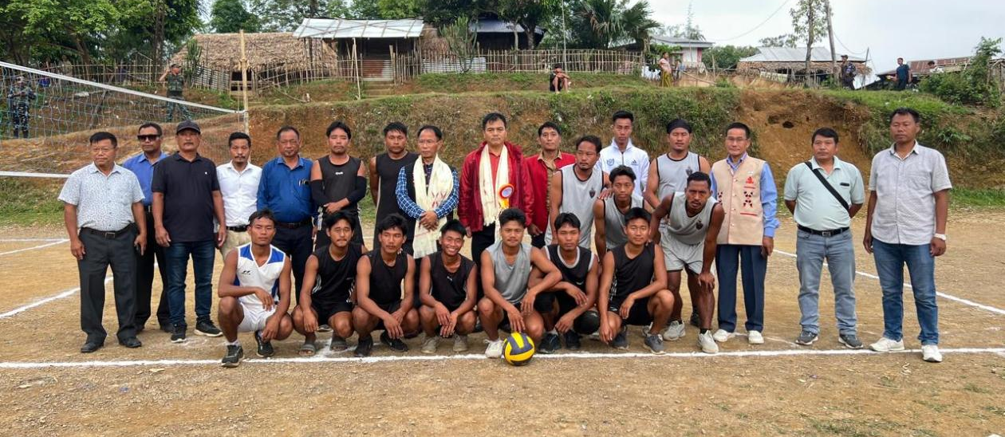

Longo, 26th April 2025: Tirap Deputy Commissioner (DC) Techu Aran graced the Volleyball Final Tournament at Longo, organized by the Longo Baptist Church, in the presence of Guest of Honour Shri N. L. Naam, EAC Lazu, along with the Chief, Gaon Burahs (GBs), and Gram Panchayat Chairperson (GPC) of Longo village.
While attending the final match, the DC appreciated the Longo Baptist Church for organizing the volleyball tournament, which saw participation from eight teams representing Tissa-1, Tissa-2, New Kothin, Kapu, Old Tupi, New Life Foundation inmates, Committee, and LBC.In the final, played in a best-of-five format, the Tissa volleyball team defeated Kothin.
Prizes were distributed to the winners by the Chief Guest and Guest of Honour respectively. Pastor of LBC, Shri Pangkha Wangsu, expressed his gratitude to DC Tirap Techu Aran for attending the event despite his busy schedule.
Meanwhile, the DC, accompanied by EAC Lazu, visited the New Life Foundation (NLF) Rehabilitation Center at Old Tupi, where he handed over plastic raw materials for making murah (traditional stools), baskets, and other handicrafts to the in-charge of the center.
While interacting with the inmates, DC Techu Aran fervently appealed to them to wholeheartedly change their mindset and strive to become responsible individuals for the betterment of their families and society. He also appreciated NLF Chairperson Wanglee Rangyang and his team for their dedicated service. The DC emphasized that the inmates should recognize the sacrifices their parents make by investing their hard-earned money to facilitate their stay at the rehabilitation center. He also assured all possible support to the center in the future.
The Chairperson of NLF expressed gratitude to DC Tirap for his regular visits and for providing raw materials to support the inmates’ skill development through handicrafts.

