GOVERNOR’S SECRETARIAT
ARUNACHAL PRADESH
ITANAGAR

Press Communiqué
Dated Apr 25th, 2025

One-Day Training Program for Master Volunteers of Nasha Mukt Bharat Abhiyaan Held in Yupia

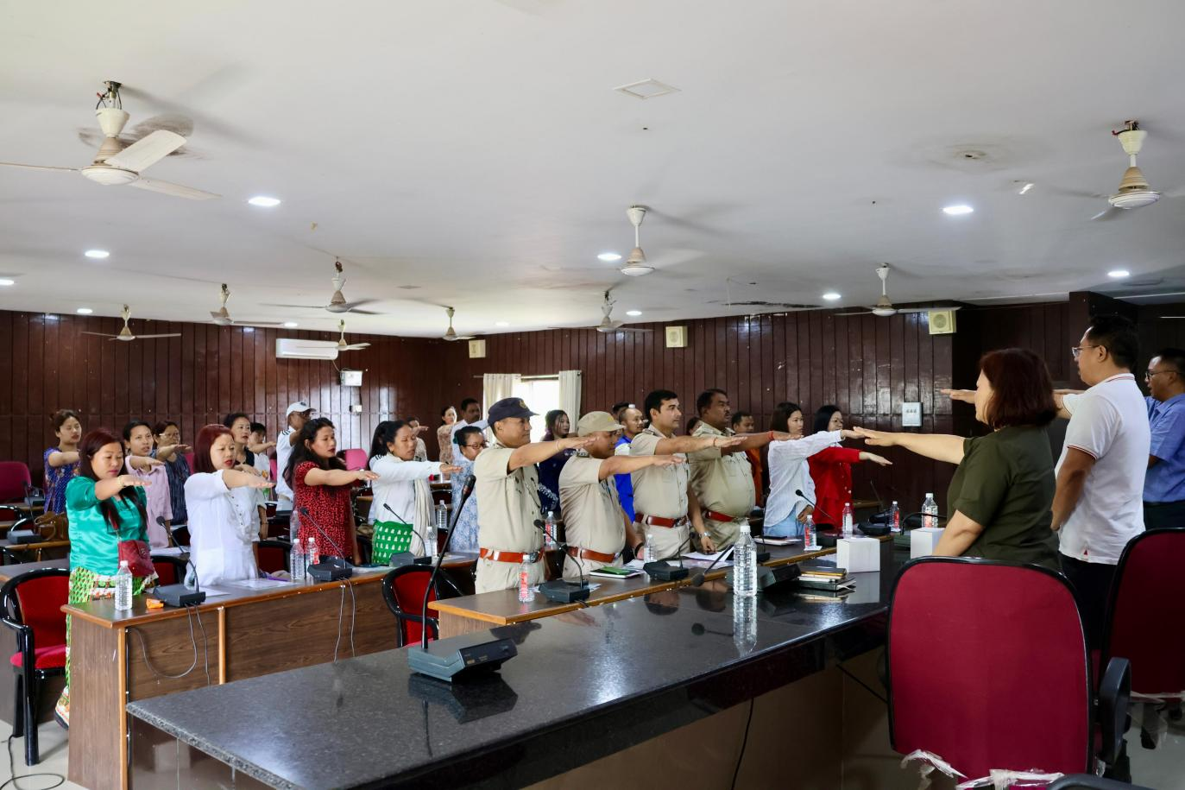
Yupia, April 25, 2025: A one-day training program for the Master Volunteers of the Nasha Mukt Bharat Abhiyaan (NMBA) was successfully conducted at the Panchayat Hall in Yupia on Friday. The event was organized by the District Administration of Papum Pare in collaboration with the State Level Coordinating Agency (SLCA), Kripa Foundation. In his inaugural address, Shri Jiken Bomjen emphasized the importance of the training in addressing addiction issues at the personal, family, and societal levels. Highlighting the detrimental impact of addiction on families and the younger generation, he called for proactive collaboration among citizens to combat the drug menace. Shri Bomjen also underscored the collective responsibility of society in ensuring a brighter future for the youth and the nation. Shri Bendang Imsong, Project Coordinator of SLCA, delivered an in-depth session on understanding addiction. He elaborated on various types of drugs, the challenges of withdrawal, the detoxification process, relapse management, and the critical role of de-addiction centers. He also stressed the importance of disseminating knowledge and creating awareness to effectively address the issue. Counseling Psychologist Shri Daewon Nongrem provided valuable insights into the psychological and social dimensions of addiction. He offered practical guidance on interacting with individuals struggling with addiction and answered queries from the volunteers, making the session highly engaging and informative.
The program concluded with the distribution of certificates to the Master Volunteers, reaffirming their commitment to the cause. A pledge for Nasha Mukt Bharat was also taken by all attendees, followed by concluding remarks by Shri Gonya Riba, Health Assistant (ICDS). The training program marked a significant step in strengthening the efforts of the Nasha Mukt Bharat Abhiyaan in the district, equipping Master Volunteers with the knowledge and tools needed to combat addiction and foster a drug-free society.
