GOVERNOR’S SECRETARIAT
ARUNACHAL PRADESH
ITANAGAR

Press Communiqué
Dated Apr 25th, 2025

One-Day Legal Awareness Programme conducted at Jengging

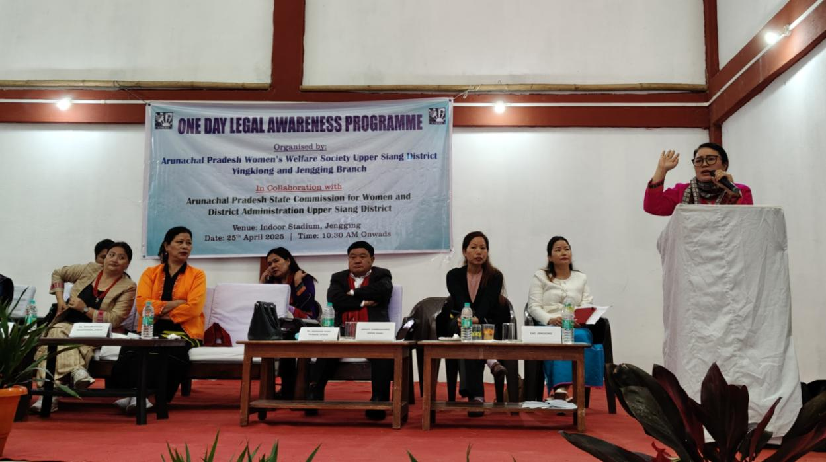
Jengging April 25’2025 : The Arunachal Pradesh Women’s Welfare Society (APWWS), Yingkiong and Jengging Branch, in collaboration with the Arunachal Pradesh State Commission for Women (APSCW), Itanagar, successfully organized a one-day legal awareness programme at Indoor Stadium, Jengging today on 25th April’2025. The programme was aimed to inform and empower the local community, especially women and youth, through sessions on legal rights, digital safety, health, and social empowerment.
The event included key sessions on the New Criminal Laws (NCL), Safer Internet Day, and women’s health, delivered by knowledgeable resource persons District Police Inspector Ms. Oyin Tari, Shri Vijay Sahu and Ms.Kago T.Yasung, Member, APSCW, Itanagar respectively.
Chairperson APSCW Ms. Kenjum Pakam, while addressing the participants, emphasized the need for girls’ education, prevention of early marriage, gender equality and monitoring screen time among children. Addressing the challenges posed by the digital age, Ms. Pakam also highlighted serious issues affecting women through social media, while citing the cases reported in Commissions where women often fall prey to online traps such as forming relationship over social media, only to later face domestic violence and other forms of abuse. She urged the participants to especially young women, to be cautious in online interactions and to be aware of their legal rights. She also highlighted the significant role of self-help groups (SHGs) in achieving financial independence and empowerment for women. She further urged participants to avail the benefits of various Govt policies and welfare programme designed for upliftment and empowerment of women.
Vice- Chairperson APSCW Ms. Nabam Yahi Tad spoke passionately about women empowerment and their contributions to building a healthy society, pointing out that women perform nearly 80% of tasks both at home and outside, yet their efforts often go unrecognized. She encouraged women to stand up for their rights, uphold cultural values, and support local products and artisans. Expressing her concerned over misuse of protective law by certain individuals, she appealed to all women to use the law in the rightful way, for the purpose it was intended-to protect, empower and uphold justice.
Ms. Kago T.Yasung, Member of APSCW, delivered session on women’s health with special emphasis on cervical cancer awareness and prevention. She educated participants on early symptoms, the importance of regular screening, HPV vaccination and need for health education among women to reduce risk and promote early detection.
Smti. Ngurang Nama, Member, APSCW, elaborated on the powers and functions of the Commission, informing the participants that over 350 cases have been taken up during their tenure. She shared a significant success story of the Commission’s recommendation to increase age relaxation for contractual government employees, which was recently approved by the State Cabinet. Additionally, she advised the participants to encourage court marriages among the younger generation, emphasizing legal security and the importance of proper documentation in today’s society.
Meanwhile, the Deputy Commissioner Talo Jerang who also attended the programme, in his address appreciated the initiative by APWWS and APSCW for conducting such programme at Jengging. “This will go a long way in empowering women to know their legal rights and responsibilities. In fact, men should also shoulder the responsibility to ease the burden carried by women. We should respect women-not just in words but in our actions too” he said. He also urged APSCW to identify regions or societies where women are most vulnerable and to create awareness among men about respecting women and sharing responsibilities equally from household to all spheres of life to promote a gender equal society.
The programme was administered by EAC Jengging Ms Maloti Tamin, who efficiently coordinated the proceedings and ensured smooth conduct of the sessions.
The programme concluded with vote of thanks remarked from APWWS Yingkiong Branch Vice President Smti Kasimang Jopir expressing deep gratitude to all guests, speakers and attendees for their valuable presence and support reaffirming their commitment to spreading legal awareness and building more empowered society.
The HoDs from various department, all ranks and files of APWWS Yingkiong and Jengging branch, Gaon Buras, Self Help Groups, Karko legends, local residents especially women and youths of Jengging, Karko, Gosang and other nearby villages and police personnel participated enthusiastically.
