GOVERNOR’S SECRETARIAT
ARUNACHAL PRADESH
ITANAGAR

Press Communiqué
Dated Apr 25th, 2025

Deputy Chief Minister Chowna Mein Conferred Honorary Doctorate by Gauhati University
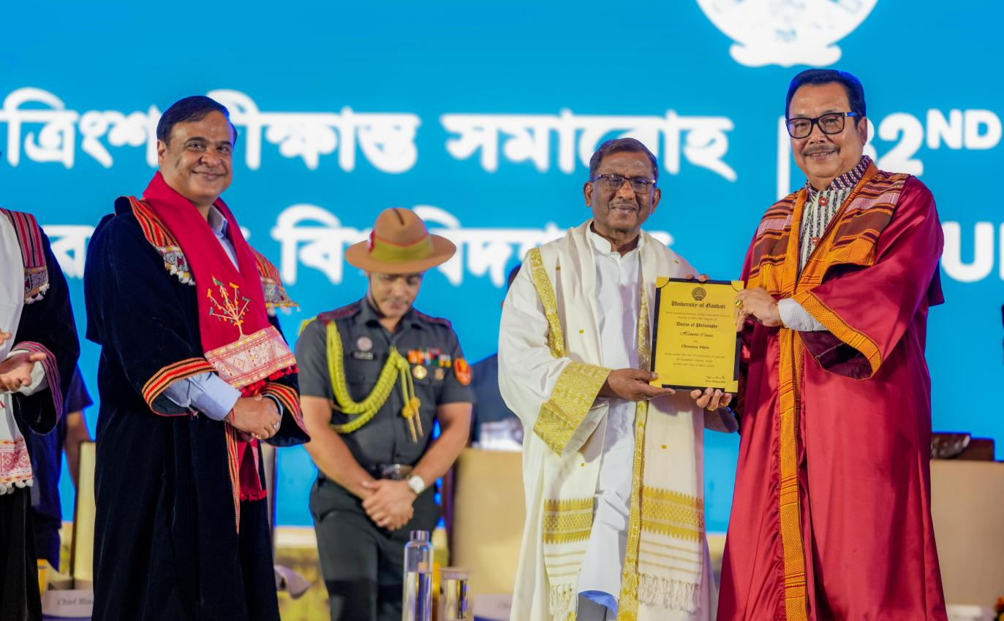

Guwahati, April 25, 2025: Deputy Chief Minister Chowna Mein was conferred the degree of Doctor of Philosophy (Honoris Causa) by Gauhati University, Assam, during its 32nd Convocation held here today in Guwahati.

The honorary degree of Doctor of Philosophy was conferred to Mein in recognition of his multifaceted contributions to political leadership, cultural preservation, and social development. He served as Speaker of the Arunachal Pradesh Legislative Assembly from 1998 and held key ministerial positions, including Finance, Power, and Non-Conventional Energy Resources. As Deputy Chief Minister since 2016, he played a vital role in transferring hydropower projects from private developers to public sector undertakings, significantly impacting the state’s development. In 2023, he was appointed Chairman of the North-Eastern Regional Power Committee, underscoring his leadership in regional energy cooperation.

The award also highlighted that Mein was instrumental in revitalising the Tai Khamti language and culture. As a founding member of the Tai Khamti Heritage and Literary Society, he helped revise the Tai Khamti script and promote folk songs and music. His commitment to cultural preservation is also reflected in his role in constructing the Golden Pagoda (Kongmu Kham) in Namsai, establishing an old age home within the complex, and supporting the welfare of senior citizens.

In addition to his cultural work, Mein has been a strong advocate for regional connectivity. He pushed for the reopening of the historic Stilwell Road, connecting Arunachal Pradesh with Myanmar and Southeast Asia, which aims to strengthen cultural and trade ties between India and ASEAN countries. Under his initiative, he also helped to secure Geographical Indication (GI) status for 18 indigenous products of Arunachal Pradesh and spearheaded the State Core Committee for successful documentation of 220 unsung heroes of the state, in collaboration with Rajiv Gandhi University, which he helped transform into a central university.

Acknowledging the honour, Mein expressed his deep gratitude, stating, “It is an honour to be acknowledged by Gauhati University, the premier institution of higher education in Northeast India and one of the most sought-after postgraduate institutions in the country. I accept this recognition with gratitude and humility.”

The honour was conferred upon him by the Governor of Assam and Chancellor of Gauhati University, Lakshman Prasad Acharya, in the presence of Chief Minister of Assam, Dr. Himanta Biswa Sarma, Education Minister Dr. Ranoj Pegu, Chief Secretary Dr. Ravi Kota, Deans and other distinguished guests.

Chowna Mein extended his heartfelt thanks to the Chancellor, Vice Chancellor Prof. Nani Gopal Mahanta, Members of the Executive Council, and the entire academic fraternity of Gauhati University for this recognition.

The Deputy Chief Minister further said that he was deeply motivated by the recognition to continue his work towards cultural preservation and its promotion and to public service.

