GOVERNOR’S SECRETARIAT
ARUNACHAL PRADESH
ITANAGAR

Press Communiqué
Dated Apr 24th, 2025

CM Pema Khandu Honors Martyr Tage Hailyang with Rs 50 Lakh Aid, Job, and Memorial Announcement

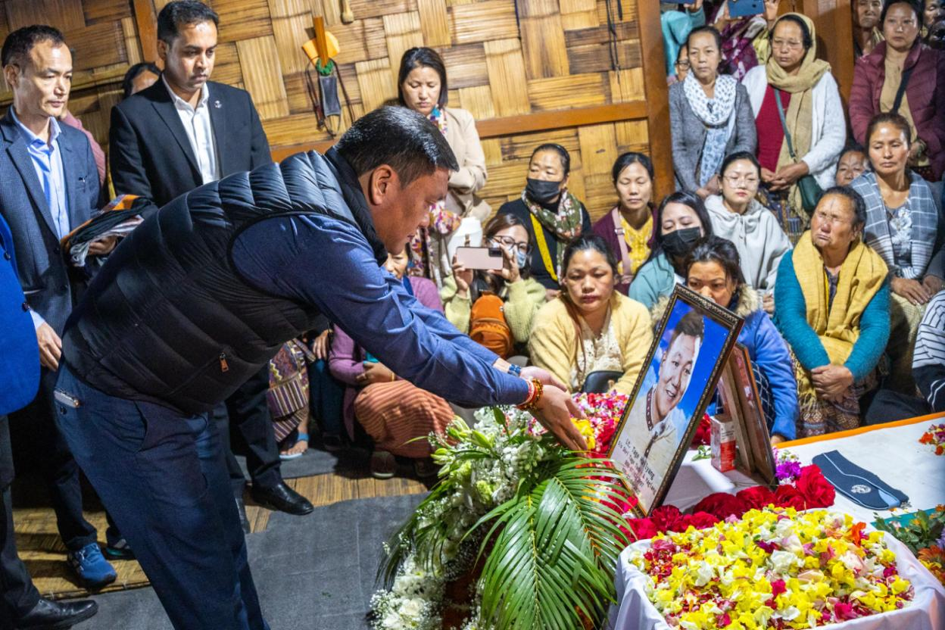
Chief Minister Pema Khandu today announced Rs 50 lakhs and a government job for a family member of Late Corporal Tage Hailyang, who was among the 26 shot dead by terrorists at Baisaran near Pahalgam in Kashmir on April 22.
Khandu, who visited late Hailyang’s native village Tajang in Ziro, Lower Subansiri this morning, paid floral tributes to the mortal remains of the late airman and consoled the grieving family members and relatives.
He also announced that the state government will construct a permanent memorial of late Hailyang in the village.
“In the face of grave danger, Tage Hailyang demonstrated exceptional courage. He had the chance to escape but chose instead to protect those around him. Risking his own life, he guided civilians to safety, helping them escape the line of fire. His selflessness in that critical moment stands as a rare and inspiring act of bravery,” said Khandu.
Offering his deepest condolences, Khandu said that the loss is beyond measure, and the people of Arunachal Pradesh stand in solidarity with the family during this time of profound sorrow.
Condemning the heinous act of terrorism, Khandu observed that Pakistan’s continued sheltering of terrorist elements is a grave threat to global peace and called for resolute action.
“I appreciate the firm stand of Hon’ble Prime Minister Shri Narendra Modi ji and am confident that under his leadership, the nation will respond with the strength and resolve that such a grave sacrifice demands,” he said.
He further said that late Hailyang’s inspiring journey - from his early education in Ziro and Haryana’s Vanvasi Kalyan Ashram - to his graduation from Don Bosco College, Itanagar, and his dedicated service in the Indian Air Force since 2017, is a shining testament to the strength, discipline, and patriotism of the state’s youth.
“Late Tage Hailyang’s legacy will endure. His name will forever be etched in the history of Arunachal Pradesh as a symbol of valour, and his sacrifice will continue to inspire generations to come,” Khandu added.

