GOVERNOR’S SECRETARIAT
ARUNACHAL PRADESH
ITANAGAR

Press Communiqué

Dated Mar 9th, 2025

Unying Aran Celebrated With Traditional Fervor And Gaiety
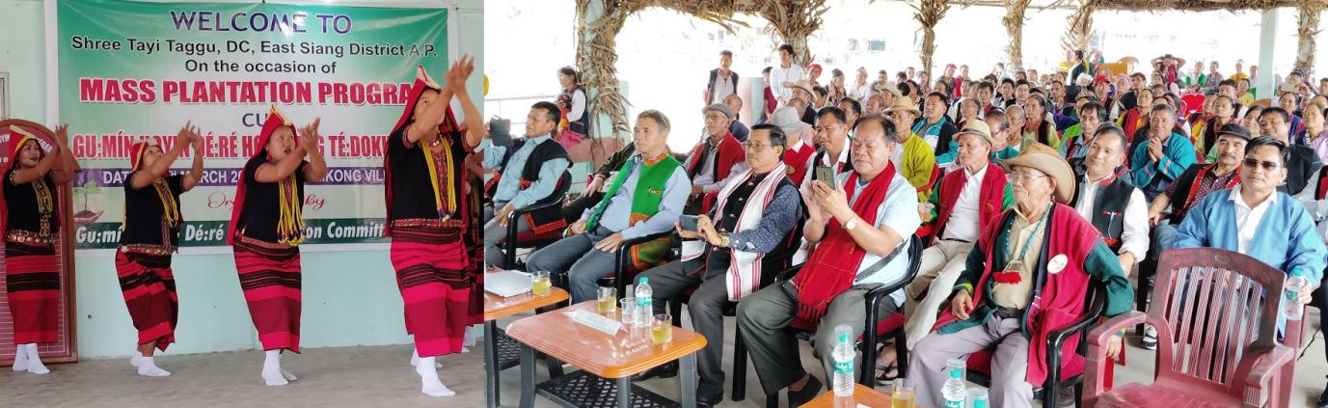

PASIGHAT, Mar 9: Unying Aran festival of the Adi community was celebrated at Mekong village under Ruksin Subdivision, East Siang district with traditional fervor and gaiety. Joining the celebration East Siang Deputy Commissioner Tayi Taggu today on Mar-9 (Sunday) urged the Adi community to carry forward their ancestral culture for their younger generations. He opined that all members of society engage together and celebrate the moment during Unying Aran for the well being, happiness and glory of family, community and all human beings. Taggu asked the elite members of the society to be dedicated for socio-economic and educational uplift of the local people. Community people should work for overall development, he advised adding that such celebration brings unity and peace and inspire the people to maintain cordial relation and better understanding among community members.

The DC appreciated the organizing committee President Agin Taboh, Secretary Tapium Taboh and their associates for celebrating the festival in a befitting and grand manner and said that it symbolizes the deep rooted culture and traditional values of the community. The very impressed DC on the occasion asserted that Mikong village has the potential to be declared as the “Cultural Capital of East Siang District”. He assured to take initiative to grant 2.5 lakhs for construction of fencing of the village Dere in the public interest and spared a small amount for promotion of cultural activities. Taking privilege, Taggu explained how wild animals and birds etc were essential for human habitation and discouraged hunting practices. Early this morning Taggu planted saplings along with the DPO Tatak Mibang and villagers in mass plantation drive organized by the community members.

