GOVERNOR’S SECRETARIAT
ARUNACHAL PRADESH
ITANAGAR

Press Communiqué
Dated Mar 8th, 2025

Thrizino Celebrates International Women's Day
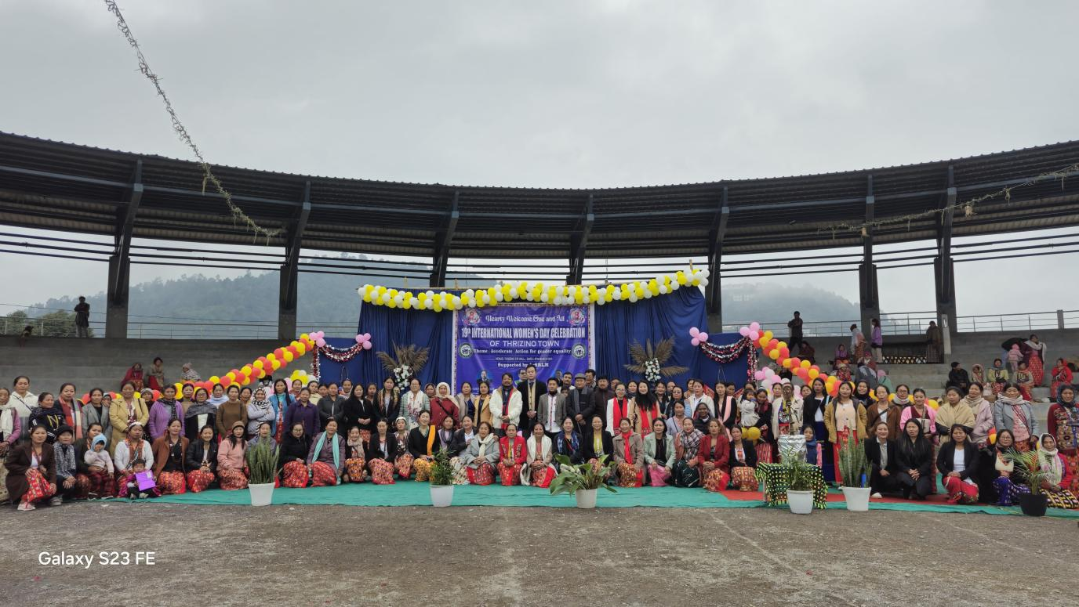
Thrizino, 8th March: The Women Welfare Association of Thrizino, in collaboration with the Department of IPR, West Kameng, and ArSLM, celebrated International Women’s Day in Thrizino. Attending as the Chief Guest, Shri Topek Kakki, ADC Thrizino, spoke about the menace of drugs. He highlighted how a single individual’s drug addiction can negatively impact their entire family and society. “Many times, when a drug abuser is sent to rehab, they are taken away before completing their session due to fake complaints raised by the abuser themselves, often convincing their parents to withdraw them,” he stated. Kakki also emphasized the need for collective support to eradicate drug abuse from society. Additionally, he appealed to the youth, especially young girls, to refrain from early marriages and instead focus on their education and careers. Advocate Ajit Sasusow and the General Secretary of the All (Hrusso) Aka Students’ Union also spoke on gender equality, women’s rights, and related issues. Various cultural competitions were organized to mark the occasion. The event was attended by SHGs, local NGOs, women of Thrizino, PRI members, ArSLM representatives, and officials.

