GOVERNOR’S SECRETARIAT
ARUNACHAL PRADESH
ITANAGAR

Press Communiqué
Dated Mar 8th, 2025

International Women’s Day celebrated in Likabali
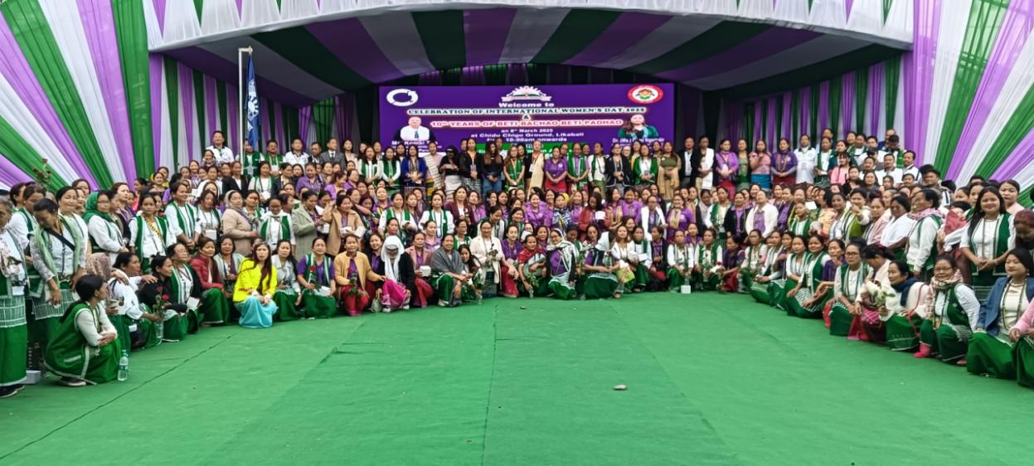
Moving a bit away from the usual style of celebrating the International Women’s Day, the day this year was celebrated in an unprecedented manner in Lower Siang District at Likabali involving the district Administration and the public of the district. While turning it into a district level celebration, the Deputy Commissioner Rujjum Rakshap led it from the front by organising it meticulously involving all male employees posted in the district including the male members of the public to make it unique, participative and emotionally giving a thrust to empowering women, as well. The daylong programme was attended by women from every circles of the district in large number, who had not only assembled at the venue to join in it but had actively taken part in all events chalked out for the day.
At the main function, which was held at the Chido Chigo General Ground, Likabali, prominent women achievers of the district in different fields & professions were felicitated by the District Administration. Besides the pioneers and founding members of Women Welfare Society a few successful PLFs and SHGs working under the ArSRLM in the district were also felicitated. Prominent persons felicitated today included Champion Arm Wrestler, Pakjar Taipodia, Internationally acclaimed Body Builder, Paklu Taipodia and eminent Fashion Designers & entrepreneurs of the country, Tonu Riba Ete.
Shri Rakshap while acknowledging the immense response shown by the women has termed the present women as the ‘emerging power of the world to be reckoned with’ in the days to come. Through his effortless narration of rhapsodies, he called upon the women folk not to tread behind the male counterparts as they did in the past but rub shoulders with them so that the future of the state is safe and the society does not move astray. He made a special mention of the contributions of the ArSRLM for their revolutionary contributions they make by bringing together the erstwhile scattered dreamless rural women into a single powerful platform in the form of Self Help Groups (SHGs) and equipping those with necessary training and needed motivations and turning them into vibrant sustainable economic changers.
The President of Arunachal Pradesh Women Welfare Society, Lower Siang District Unit Smti. Mijir Riba Taipodia while giving her women’s day message to the district thanked the District Administration and the Public of Lower Siang District for organising the mega event which she said was never ever seen before elsewhere in the state andworth emulating by others too. She appreciated the women of the district for the huge turn out that practically embodied the theme of the International Women’s Day 2025 theme- #AccelerateAction for shifting to gender equality and thus empowering women.
Retired Director of Women & Child Development Department of state Mrs. R.T. Riba had an elaborative deliberation on the role of women in shaping a family, a society and the world at large. She turned emotional while appreciating the unprecedented magnitude of celebration of the day and termed the noble initiative of the district administration as ‘honouring and empowering the women.’
Resource Persons Ms. Kombin Tao and Dr. (Ms.) Doge Ngomdir had separate exhortation lectures on varied topics on the multiple roles of women in context of the emerging world trend on the backdrop of International Women’s Day with the theme #Accelerate Action.
