GOVERNOR’S SECRETARIAT
ARUNACHAL PRADESH
ITANAGAR
Press Communiqué
Dated Mar 7th, 2025

Secretary (Border Management) Inspects Border Delevopment In Dibang Valley
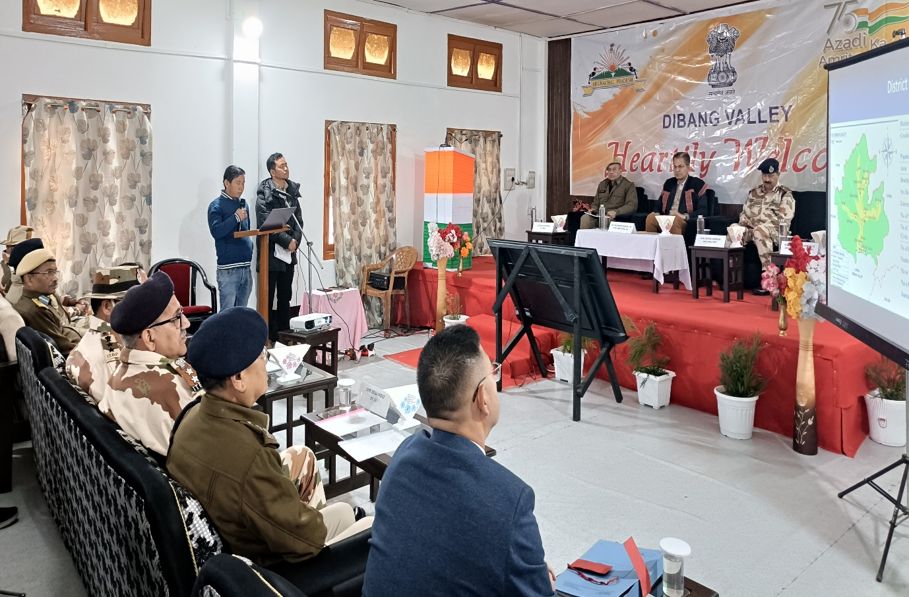
Anini, the 7th March 2025: Secretary (Border Management) MHA Govt of India, Dr Rajendra Kumar, IAS is on a two visit to the district to inspect the various infrastructural and developmental projects being undertaken by Ministry of Home Affairs in the border areas.
Chairing a review meeting regarding progress of projects under Vibrant Village Programme and roads under the ICBR project, the Secretary advised the departmental officials to ensure no procedural lapse occurs during project submission to the ministry as it creates unnecessary hurdle in project execution and that the proposals be uploaded only through the prescribed channel of the ministry.
While commending the District Administration and various stakeholders involved in border area development, it was suggested that efforts must be made in the direction of building timely and attractive infrastructure projects to stop outmigration of the villagers. Ample avenues must be created for providing livelihood opportunities while ensuring security at the frontiers.
The status of ICBR roads, Frontier Highways and infrastructure at Border Outposts were also highlighted by the representatives of NHIDCL, BRO and ITBP.
The Secretary will be inspecting various ICBR roads and will also interact with villagers of Vibrant Villages. He is being accompanied by Shri Rajiv Sharma (CE Project Udayak BRO) Shri Deepka Sanduja, DIG (ENG) ITBP, Col.(Retd) Arindam Handique (GM(P) NHIDCL) besides various officials of District Administration.
