GOVERNOR’S SECRETARIAT
ARUNACHAL PRADESH
ITANAGAR

Press Communiqué
Dated Mar 7th, 2025

DECLARATION OF WEST SIANG AS AVOIDABLE BLINDNESS FREE DISTRICT
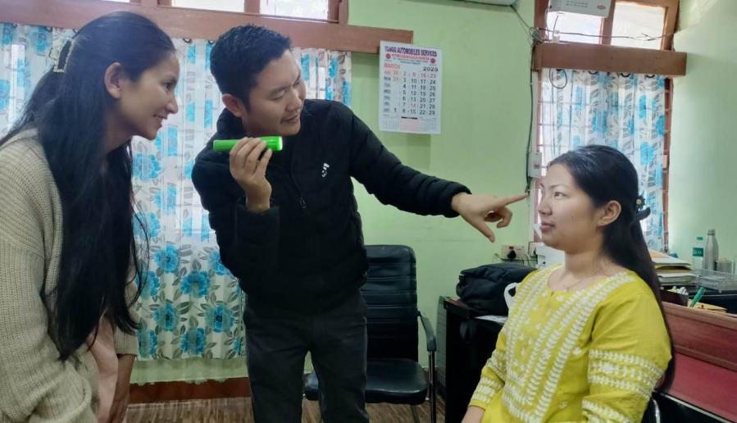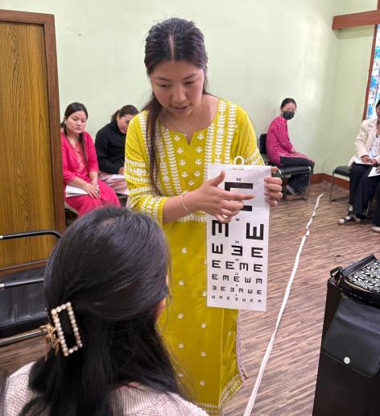
Aalo the 7th March 2025: The National Programme for Control of Blindness and Visual Impairment is proceeding with the Declaration of West Siang District as Avoidable Blindness Free by 31st March 2025. In run up to the event, the Health Department is engaged in mobilization of community to cooperate in campaign, training of staffs and volunteers involved to achieve the target. The ASHAs and other primary health care workers are already working in the field and all the rural communities have been screened. In this direction, a training of volunteers for screening of Township area was conducted today by the Ophthalmologists and Para- Medical Ophthalmic Assistant. The screening of the township area for operable Cataract cases will be started immediately and all the operable cases detected in rural and urban areas will be operated Free of cost at General Hospital, Aalo .

