GOVERNOR’S SECRETARIAT
ARUNACHAL PRADESH
ITANAGAR

Press Communiqué

Dated Mar 28th, 2025

Arunachal Pradesh Accelerates Ease of Doing Business Reforms: Deputy CM Calls for Immediate Action
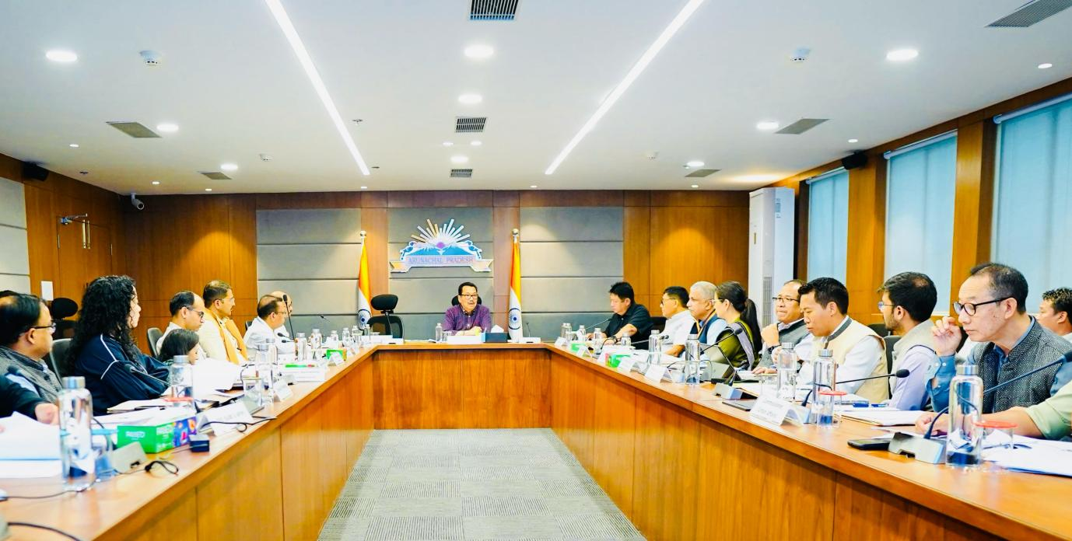

Itanagar, March 28 – In a significant move to enhance the business environment in Arunachal Pradesh, Deputy Chief Minister, Chowna Mein chaired a high-level review meeting on the state’s Ease of Doing Business (EoDB) reforms.
DCM, in his address, stressed the urgency of full implementation of the EoDB Act 2021, directing all departments to digitize their services and frame EoDB Rules to formalize the process. He emphasized the importance of timely service delivery and appropriate action under Citizen Services Delivery Acts for any lapses. He further urged departments to embrace a proactive approach to reducing procedural bottlenecks and facilitating a business-friendly environment.
R.K. Sharma, Secretary (Planning & Investment) in his welcome speech underscored the State’s commitment to a seamless and investor-friendly regulatory framework. He highlighted that the EoDB Act 2021 mandates the integration of all departmental services into the EoDB portal, ensuring streamlined processes and greater transparency.
While Tabe Haidar, CEO (APIIP) and Joint Director (Investment) presented the status of implementation of EODB in the State, highlighting Arunachal Pradesh’s progress, the state’s recognition as an ‘Aspirer’ in the Government of India’s EoDB rankings and its distinction as the ‘Most Improved Small State in Governance’ by India Today. He also informed that Arunachal Pradesh is the first Northeastern State to integrate with the National Single Window System and that its EoDB portal is now generating revenue, reflecting the effectiveness of the digital transition.
The meeting resulted in key decisions, including the implementation of the Reduction of Compliance Burden (RCB) framework, mandatory onboarding of all departmental services onto the EoDB portal, creation of a land bank to attract investments, and the development of a comprehensive investment policy. Additionally, departments were also directed to phase out manual processes after adequate training and awareness campaigns to ensure a smooth transition to digital governance.
The session concluded with a vote of thanks from Pallab Dey, Director (Planning), reaffirming the state’s commitment to making Arunachal Pradesh a preferred destination for investors and businesses
The meeting was attended by Advisor to DCM, Additional PCCF, Commissioner (Industries/Trade & Commerce), Commissioner (Agriculture/Horticulture), Secretary (Trade & Commerce), Secretary (Industries), Secretary (Transport), Secretary (Health), Secretary (Tourism), Secretary (Labour & Employment), Secretary (Legal Metrology), Member Secretary (State Pollution Control Board), Director (Planning), among others.
