GOVERNOR’S SECRETARIAT
ARUNACHAL PRADESH
ITANAGAR

Press Communiqué

Dated Mar 28th, 2025

SEVA APKE DWAR HELD AT SUNPURA
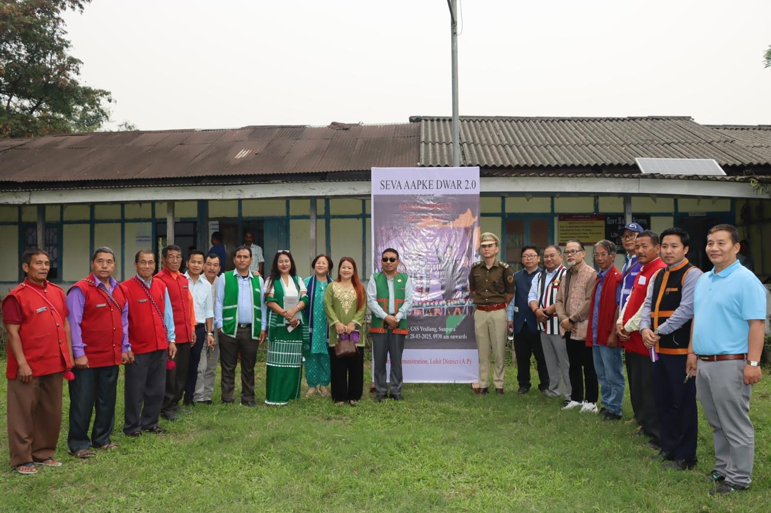

Sunpura 28th March 2025 : The "Seva Aap Ke Dwar" program was successfully held at Sunpura, Lohit District, today, and was inaugurated by KN Damo, the Deputy Commissioner of Lohit along with SP Lohit Thutan Jamba, ZPM Sunpura Angenlu Minin Chaitom. The program aimed to bring essential government services directly to the people, ensuring that the benefits of various welfare initiatives are easily accessible.
During the welcome address, the Sunpura Rakesh Tacho, SDO outlined the importance of the program, emphasizing its role in facilitating the government's outreach to the community. He highlighted that the program was a significant step toward making development more inclusive and ensuring that no citizen is left behind.
In his speech, KN Damo expressed optimism about achieving saturation in service delivery soon. He encouraged the people to take full advantage of the program and utilize the various services available at the event. He stressed that such initiatives are vital for inclusive growth, which ensures that development reaches every individual, especially those in remote areas.
KN Damo also spoke about future plans to improve the region's education system. He announced that in the coming days, each government officer would be tasked with adopting a school, with the goal of improving infrastructure, resources, and overall educational standards. This initiative would enable officers to take a more hands-on approach in shaping the future of local education.
Furthermore, KN Damo highlighted the importance of responsible citizenship. He called upon the citizens to not only benefit from government programs but also to give back to society by actively contributing to community development. He stressed the idea of collective responsibility and the need for individuals to play a role in nation-building.
During the program, KN Damo took the time to visit all the stalls set up by various government departments. He interacted with the people, listening to their concerns and taking stock of the services being provided. These stalls offered a wide range of services, from healthcare and social welfare to education and agriculture, making it a comprehensive event.
Certificates and numerous benefits were distributed to the attendees, with the aim of ensuring that people were receiving the support they needed. The program saw active participation from multiple government departments, including health, rural development, ArSRLM, Horticulture, Agriculture, Animal Husbandry and education etc, each playing a key role in the event's success.
This initiative not only helped in providing essential services but also strengthened the bond between the administration and the community. It underscored the importance of inclusive development and reaffirmed the commitment of the local government to improving the quality of life for all citizens in the region.
