GOVERNOR’S SECRETARIAT
ARUNACHAL PRADESH
ITANAGAR

Press Communiqué

Dated Mar 28th, 2025

Meeting on Panchayati Raj Electoral Roll Summary
Revision Held
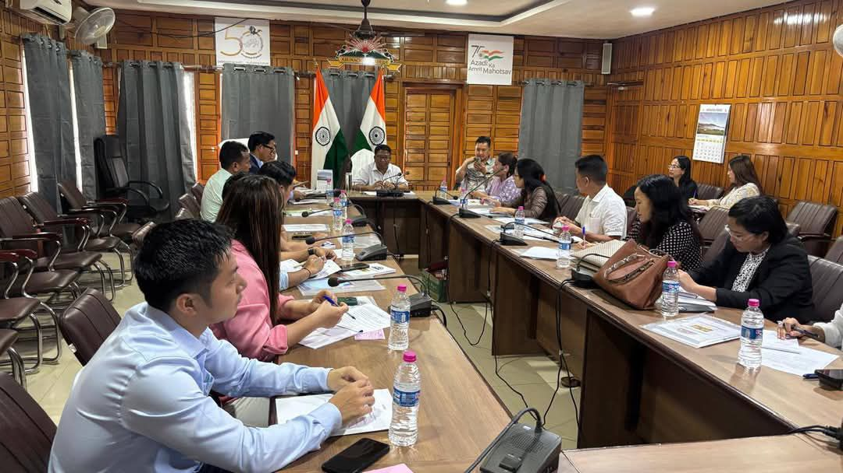

Yupia, 28th April 2025: A meeting was convened today at the DC Conference Hall, Yupia, by the District Election Officer (Panchayati Raj) with all Electoral Registration Officers (EROs) and Assistant Electoral Registration Officers (AEROs) of Papum Pare District to discuss the ongoing summary revision of Panchayati Raj electoral rolls. The DC-cum- DEO (PR) Jiken Bomjen emphasized the importance of preparing error-free electoral rolls and directed all EROs and AEROs to conduct thorough verification to eliminate any discrepancies. Specific instructions were given to remove the names of deceased voters and rectify duplicate or multiple entries to uphold the integrity of the electoral rolls.
The DEO (PR) highlighted the significance of this revision, particularly as it is being conducted after a gap of five years, and urged all officers to exercise the highest level of diligence throughout the process. During the meeting, the EROs shared their field experiences from previous elections, outlining key challenges encountered during electoral roll preparation. These included issues with voter verification, duplicate entries, and last-minute corrections. Based on these insights, the DEO (PR) directed all officers to implement corrective measures to ensure a more streamlined and error-free revision process. The meeting concluded with a vote of thanks delivered by the EAC (PR) Smt. Dana Unna. The meeting was attended by ADC-cum-ERO Balijan, ADC-cum-ERO Sagalee, ADC-cum-ERO Kimin, SDO-cum-ERO Doimukh, AEROs, and EAC (PR), Yupia.

