GOVERNOR’S SECRETARIAT
ARUNACHAL PRADESH
ITANAGAR

Press Communiqué

Dated Mar 27th, 2025

18 Students of National Security Studies, Manipur University, Conclude Educational Field Trip to Strategic Tawang
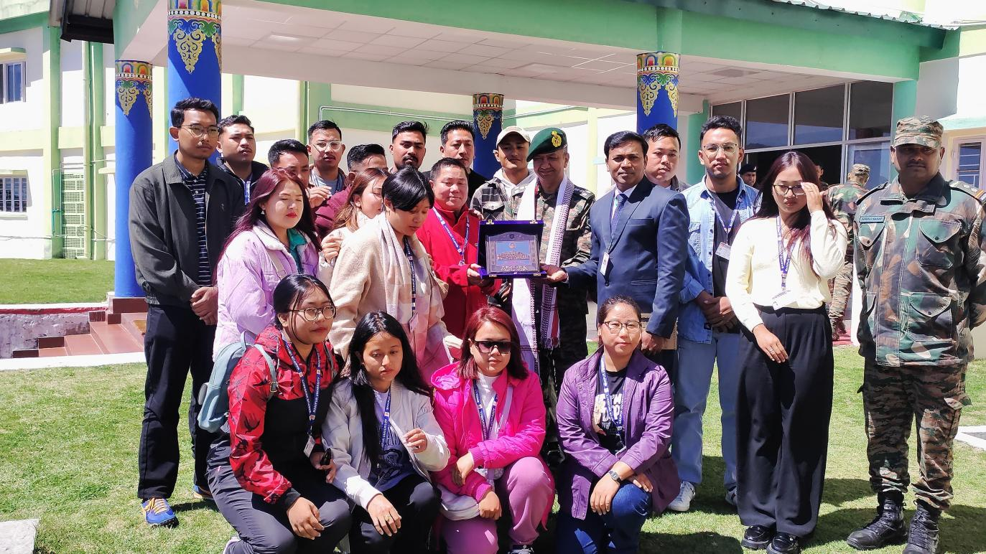

Tawang, 27/03/2025 : A group of 18 students from the Department of National Security Studies, Manipur University, successfully completed a six-day educational field trip to Tawang and the border areas, gaining invaluable insights into the strategic, historical, and cultural significance of the region.
The tour offered students a first-hand understanding of the geo-strategic importance of India’s border areas, the pivotal role of the Indian Army in national security and development, and the deep-rooted cultural heritage of Strategic Tawang. It also highlighted the harmonious civil-military relations in the region, showcasing the Indian Army’s commitment to nation-building and community engagement.
During their visit, the students interacted with the Commander, Tawang Station, who provided a comprehensive briefing on the security dynamics of the region. They explored key landmarks, including the Maj Bob Khathing Museum of Valour, Tawang Monastery, and the Giant Buddha, further enriching their understanding of the area’s spiritual, cultural, and historical legacy.
A poignant moment of the trip was their visit to the Tawang War Memorial, where they paid homage to the Bravehearts of the 1962 War. The Light and Sound Show vividly narrated the stories of courage, sacrifice, and resilience of the Indian Armed Forces, leaving a lasting impact on the students. Their visit to the Maj Bob Khathing Museum of Valour was especially significant, instilling immense pride in one of Manipur’s greatest sons, whose contributions to Tawang and the nation remain an enduring inspiration.
The educational tour concluded on a highly enriching note, equipping students with first-hand knowledge of India’s border regions, their strategic importance, and the developmental efforts being undertaken. This experience has fostered a deeper appreciation for national security, heritage, and the critical role of the Indian Army in safeguarding and uplifting remote border communities.
