GOVERNOR’S SECRETARIAT
ARUNACHAL PRADESH
ITANAGAR

Press Communiqué
Dated Mar 26th, 2025

EC commences first ever training of over 1 lakh Booth Level Officers (BLOs) at IIIDEM in batches
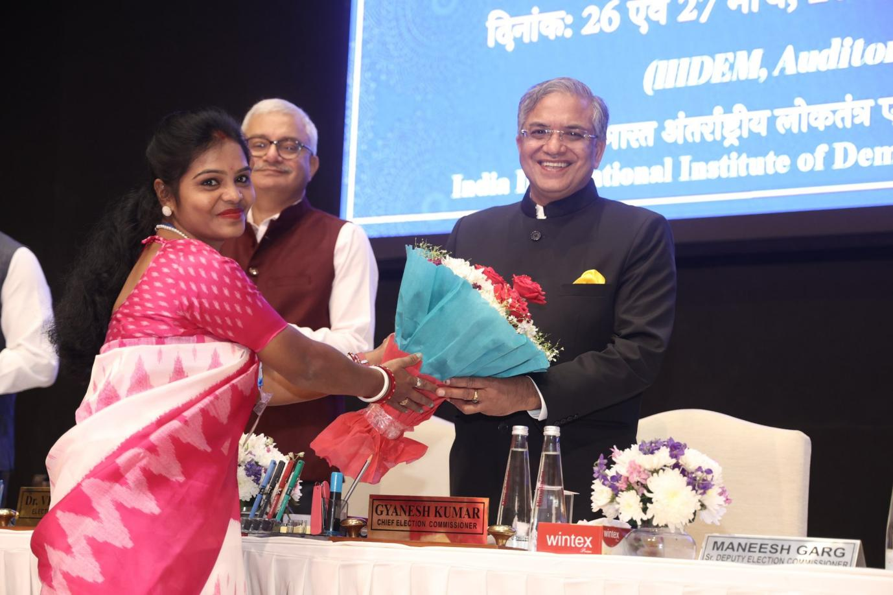

- First batch of BLOs from Bihar, West Bengal & Assam participate in 2- day training program at IIIDEM
- Continuous, practical, scenario-based training for grass root Election functionaries
- Well-trained BLOs to become Assembly Level Master Trainers to strengthen nationwide network of BLOs

CEC Shri Gyanesh Kumar inaugurated the first ever training of BLOs along with EC Dr. Vivek Joshi at India International Institute of Democracy & Election Management (IIIDEM), New Delhi today. Over 1 lakh BLOs with an average of one BLO per 10 polling stations will be trained in such training programmes over the next few years. These well-trained BLOs will forma corps of Assembly Level Master Trainers (ALMTs) to strengthen the entire network of BLOs nationwide, who are the first and most important interface betweenthe100CroreelectorsandtheCommission.
This unique capacity building program will continue in phases focussing first on poll-bound states. Currently, 109 BLOs from Bihar, West Bengal and Assam are participating in this 2-day residential training programme along with 24 EROs and 13 DEOs from Bihar, West Bengal, Assam, Kerala, Puducherry and Tamil Nadu.
The training is planned to familiarise the BLOs with their roles and responsibilities as per the RP Act 1950, the Registration of Elector Rules 1960 andinstructionsoftheCommissionissuedfromtimetotimeandtoequip them with requirements of filling relevant forms for an error free updation of electoral rolls. They will be familiarised with IT applications designed tosupport their work.
BLOs are State Government officials and are appointed by the Electoral Registration Officers (EROs) after the approval of the District Election Officers (DEOs).CECShriGyaneshKumarwhileacknowledgingthecriticalroleof EROs and BLOs in error free updation of electoral rolls, stressed that the state governments should nominate SDM level or equivalent officers as EROs, who then should appoint BLOs giving due consideration to their seniority and who areordinaryresidentofthepollingstationundertheircharge.
CEC underscored that as per Article 326 of the Constitution and Section 20 of the RP Act 1950, only citizens of India who are above 18 years of age and ordinarily resident in the constituency can be registered a selectors.

