GOVERNOR’S SECRETARIAT
ARUNACHAL PRADESH
ITANAGAR

Press Communiqué
Dated Mar 26th, 2025

District Child Protection Unit rescued a child
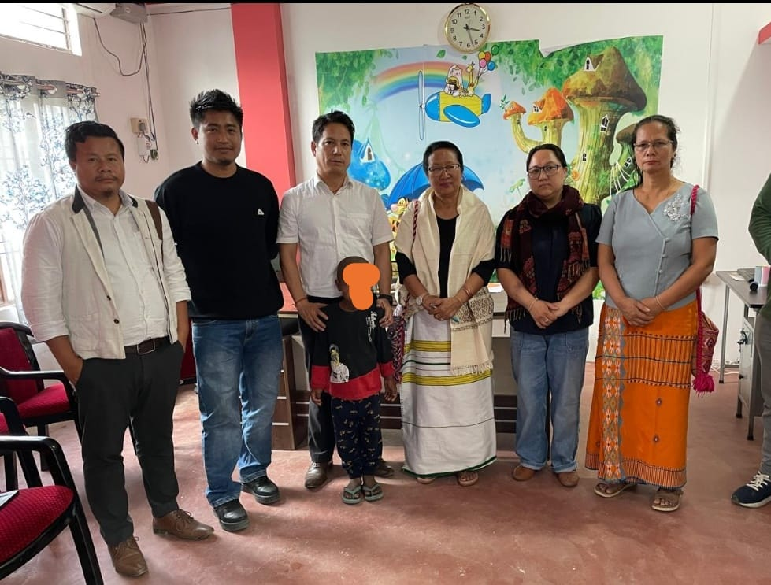

Aalo the 26th March 2025: The District Child Protection Unit of West Siang District rescued a child namely Chanchal Bhujal 8 years on 25th March 2025. A child is from resident of No.3 Jungle Barigaon Udaiguri District Assam. The rescued team was lead by Shri Mijum Doke LPO and Smty Mongam Nomuk counselor DCPU Aalo. Upon a complain received through Child helpline No. 1098. The rescued Child was presented before Child welfare Committee Aalo to Smty Marbom Riba Bagraand Smty Geter Taso CWC member. Later on the child was handed over to his parents through CWC Udaiguri Assam.
The District Child Protection Unit(DPCU) West Siang appealed the general public to refrain from engaging the children as illegal adoption, Child Labour and human trafficking these are serious offences that are non bailable and cognizable under the law.

