GOVERNOR’S SECRETARIAT
ARUNACHAL PRADESH
ITANAGAR

Press Communiqué
Dated Mar 26th, 2025

2nd SAD camp of Upper Siang Held at Karko Village
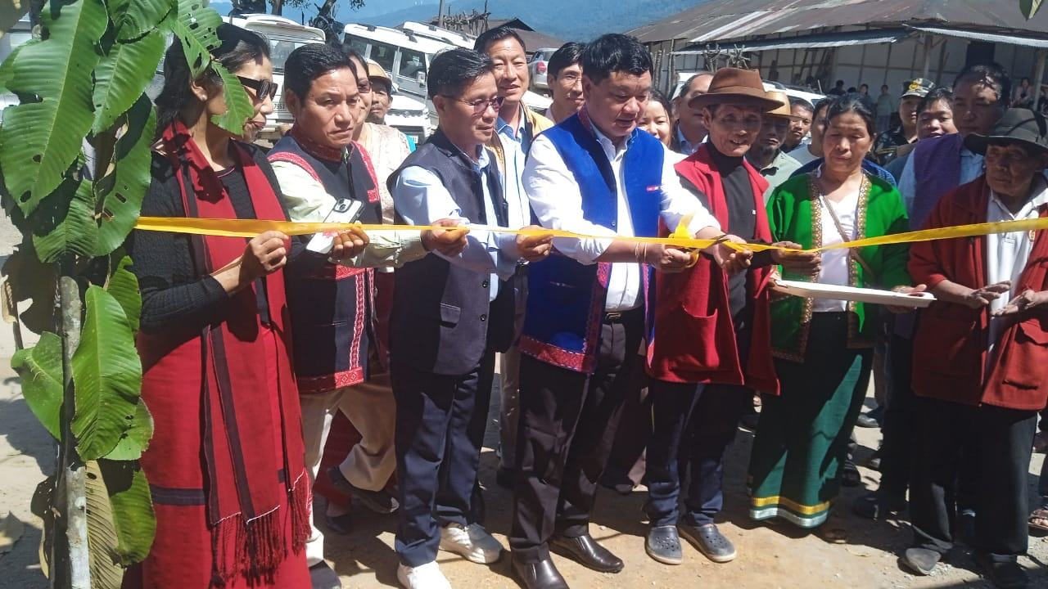

KARKO March 26: The District Administration Upper Siang conducted its 2nd Seva Aapke Dwar 2.0 at Karko village today on 26/03/2025. The camp was inaugurated by Shri Talo Jerang, the Deputy Commissioner, Upper Siang District in presence of Head of Departments, PRIs leaders, Gaon Burahs, Govt Officials and general public at Karko Dere. Altogether 440 public availed the services provided by 31 departments.
In his address to the public on the occasion DC Sri Talo Jerang highlighted the importance of Seva Apke Dwar and said ‘ this holistic initiative of the Govt aims to improve essential public services and welfare schemes by bringing facilities at their doorstep ensuring that all walks of life avail the benefits of Govt schemes’ He also highlighted benefits of various Govt schemes and urged the public to take maximum benefit of services provided during the camp. He also inspected the stalls and take stock of facilities provided by them.
During the camp, the DC also handed over rowing machine, sprayer, soil cards, gardening tools and implements distributed by Departments of Agriculture and Horticulture, Yingkiong. DAO Yingkiong informed that emoji based Soil Health Cards have been distributed to farmers so that they can easily identified quality of their soil.
DC also handed over PDS electronic Weighing machine distributed by Dept of Food and Civil Supply Yingkiong under initiative of Govt to prevent leakage of food grain in public distribution System and ensure equitable distribution of food grain. A total of 31 departments participated in the camp.
