GOVERNOR’S SECRETARIAT
ARUNACHAL PRADESH
ITANAGAR

Press Communiqué
Dated Mar 25th, 2025

Governor inaugurates two-day Higher and Technical Education Conference
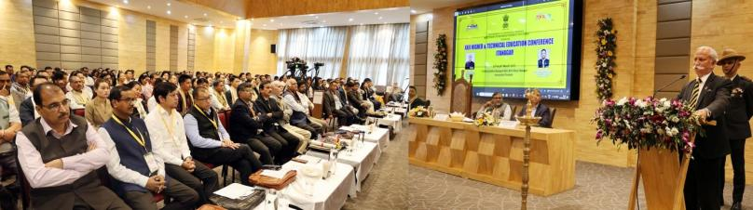
- Governor emphasizes the role of educational institutions in preparing students not only for the workforce but also for leadership roles by equipping them with knowledge, skills, and an innovation-driven mindset.

- Governor emphasizes the transformative impact of the National Education Policy (NEP) 2020

The Governor of Arunachal Pradesh Lt. General KT Parnaik, PVSM, UYSM, YSM (Retd.) inaugurated the 22nd Higher and Technical Education Conference at Itanagar on 25th March 2025. He felicitated two of the Pioneers of Higher Education in Arunachal Pradesh and conferred prestigious awards, including the Governor’s Award to undergraduate toppers of 2024, the Arunachal Pradesh State Council for Technical Education (APSCTE) Gold Medal to toppers of Government polytechnics, and the Outstanding College Teacher’s Awards during the inaugural function.
In his address, the Governor underscored the increasing significance of higher and technical education in today's rapidly evolving world. He emphasized the role of educational institutions in preparing students not only for the workforce but also for leadership roles by equipping them with knowledge, skills, and an innovation-driven mindset.
Highlighting the importance of the annual conference, the Governor noted that in an era of rapid technological advancements and shifting global demands, the event serves as a crucial platform for collaboration and innovation. The conference brings together educators, policymakers, industry leaders, researchers, and students to foster innovation in education, bridge academia-industry gaps, discuss policy development and reforms, encourage research and knowledge exchange, enhance professional development, and address emerging challenges through automation and artificial intelligence.
Highlighting the future of higher and technical education, the Governor emphasized the transformative impact of the National Education Policy (NEP) 2020. He stated that NEP 2020 aims to reshape India’s education system by focusing on skill development, entrepreneurship, and practical knowledge. It promotes flexible curricula integrating academic and practical skills, encourages early-stage vocational education through internships, and enhances students' employability by focusing on critical thinking, problem-solving, digital literacy, and creativity.
The Governor further noted that NEP 2020 fosters entrepreneurship, promotes technology-driven learning, supports startups and innovation, and aligns with the Skill India Mission to bridge the gap between education and industry demands. He stressed that Arunachal Pradesh’s higher education sector stands at a pivotal moment, facing challenges but also possessing significant potential for growth. Strategic reforms and investments in infrastructure, digital learning, vocational education, and industry partnerships can create a robust educational ecosystem that empowers students and drives socio-economic development.
Expressing optimism for the future, the Governor emphasized that with continued support from the government, academic institutions, and private stakeholders, Arunachal Pradesh has the potential to emerge as a Centre of Excellence in higher and technical education, providing its youth with better opportunities for learning and career growth.
The Governor, while complimenting the award winners urged them to aim for perfection in all spheres of life and settle for nothing short of excellence. He advised them to always lead with exemplary achievements and be a successful person.
The Governor released two books, titled ‘Understanding Adolescents’ by Dr. Sukanta Kumar Pradhan and ‘General English for APPSC, APSSB, UPSC & Other Competitive Examinations’ by M.Q. Khan and S.Khan, Principal, Dera Natung Government College, Itanagar and the ‘Basic Information of Higher Education’ Booklet, on the occasion.
State Education Minister, Shri P. D. Sona, MLA cum Advisor to Minister Education, Shri Mutchu Mithi, Chief Secretary, Shri Manish Kumar Gupta, Commissioner Education, Shri Amjad Tak and Joint Secretary (Education) Ms Nyamgal Angmo also addressed the inaugural session of the conference. Director of Higher and Technical Education Dr. Milorai Modi and Dr. AK Mishra, SLO (NSS) gave an overview of the Higher Education scenario of the State.
The Vice Chancellors of Central, State and Private Universities, Directors of Higher & Technical Education and educational institutions and deans, registrars, principals and members of the faculty of higher education institutes are attending the two-day conference.
Prof. Arup Kumar Das, former lecturer, JNC, Pasighat and Prof. of Botany, RGU, and Dr. Surya Pal Shukla, Former Principal, DN Govt. College Itanagar and Former Member, APPSC received the Pioneers Of Higher Education Award – 2024 award.
Dr. Leki Sitang, Associate Professor (History) and Vice Principal, JNC, Pasighat and Dr. Sukanta Kumar Pradhan, Assistant Professor (Education) IGGC, Tezu received the Outstanding College Teachers Award-2024 Award.
Miss Simran Jaboju, B.Sc Zoology Dngc, Itanagar , Miss Jarbie Riba, B.A (Pol. Sc.) Donyi-Polo B. Ed. College, Bank Tinali, Itanagar and Miss Mummi Tekseng, B.Com Saint Claret College, Ziro received the Governor’s Award for undergraduate toppers of 2024 as Toppers of University Examination.
Shri Bomkar Murtem, Civil Engineering, Tomi Polytechnic College, Basar received the Arunachal Pradesh State Council for Technical Education (APSCTE) Gold Medal being the topper of Government polytechnics
Dr. Tashi Dorjee Megeji Govt. College Bomdila, West Kameng District received the Best Nss Programme Officer Award-2024, while Saint Francis De Sales College, Aalo, West Siang District received the Best NSS Unit Award – 2024.
Shri Gomnia Rie, VKCTE, Nirjuli, Shri Mejet Mema and Shri Joseph Wangjen of WRGC, Deomali received the Best NSS Volunteer Award – 2024.
Miss Sangey Choto Khrimey, Don Bosco College, Jollang, Itanagar and Shri Ojing Yao, Indira Gandhi Govt. College, Tezu received NSS Commendation Certificate – 2025 for participating in RD Parade New Delhi
