GOVERNOR’S SECRETARIAT
ARUNACHAL PRADESH
ITANAGAR

Press Communiqué
Dated Mar 25th, 2025

Seva Aapke Dwar 2.0 Camp Held at Thongre Village, Over 100 Villagers Benefited
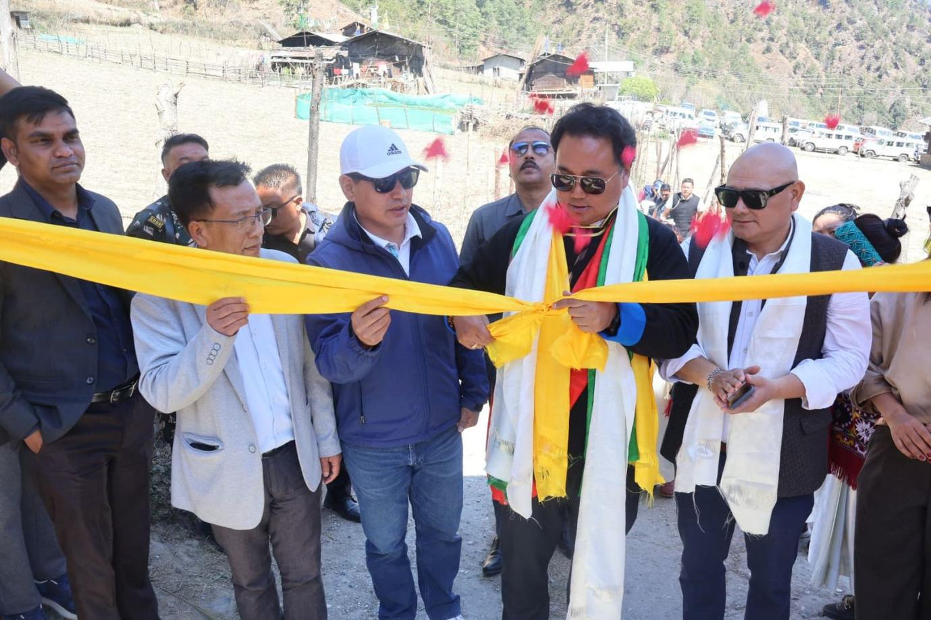

Rupa, 25th March: A Seva Aapke Dwar 2.0 camp was conducted today at Thongre Village under Rupa Sub-division, West Kameng District, Arunachal Pradesh.
The camp was inaugurated by HMLA of 5-Kalaktang (ST) AC, Shri Tseten Chombay, in the presence of ZPC West Kameng, Shri Karma Dorjee Thongdok, ADC Rupa, Shri Lobsang Tsetan, HGBs, GBs, DHODs, PRI leaders, and villagers. A total of 20 departments participated in the camp.
Addressing the villagers, HMLA Shri Tseten Chombay emphasized the importance of skill development and beneficiary schemes. He also highlighted the potential for tourism development in the area and urged villagers to preserve their age-old traditions and heritage structures.
ZPC Shri Karma Dorjee Thongdok briefed the villagers on the significance and objectives of the camp, encouraging them to avail the services provided.
During the visit, HMLA inspected the ongoing Water Treatment Plant project and directed the concerned authorities to ensure its timely completion. He also visited the local craft and weaving center in the village.
As part of the initiative, the Horticulture Department distributed certificates and tools to beneficiaries, while the Agriculture Department and the Department of IPR distributed pamphlets to spread awareness about various government schemes.
Over 100 villagers from Thongre and nearby villages availed the services provided by the 20 participating departments during the camp.

