GOVERNOR’S SECRETARIAT
ARUNACHAL PRADESH
ITANAGAR

Press Communiqué
Dated Mar 25th, 2025

District Health Society Papum Pare District (Rural) Yupia Launches National De-worming Day Programme
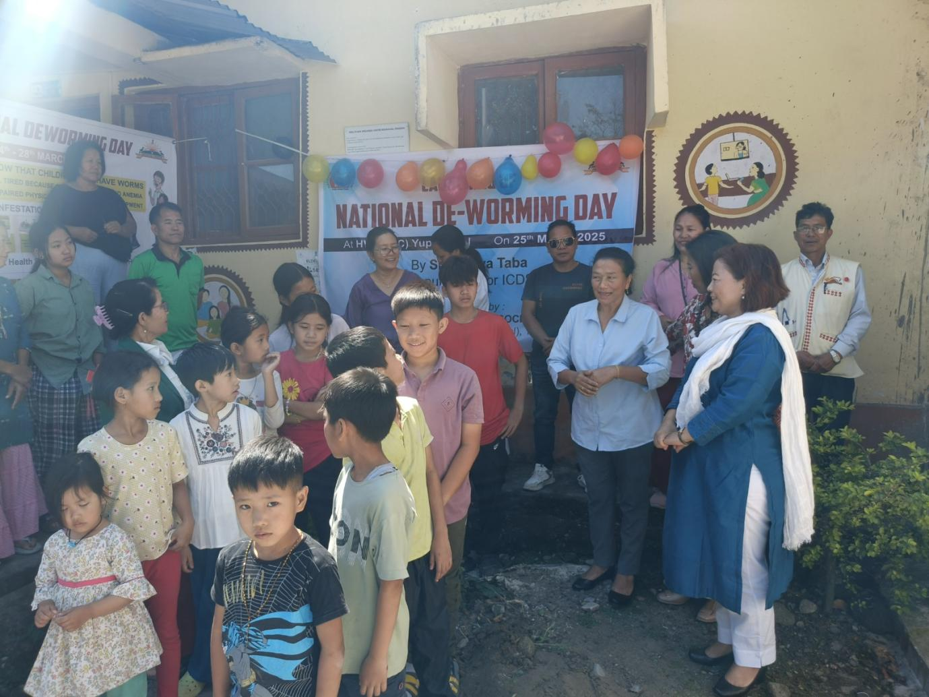

Yupia, March 25, 2025: The District Health Society Papum Pare District (Rural) Yupia today launched the National De-worming Day (NDD) programme at the Health & Wellness Centre (SC) Yupia. The programme aims to deworm all children aged 1-19 years in the district.
Smt. Taba Jaya, Deputy Director ICDS, graced the occasion and launched the NDD programme for the district. Emphasizing the importance of good health in shaping a child's future, she said, "The age of children up to nineteen years are the crucial years when the future of his/hers is dictated, and a good health of those growing children are to be prioritize."
Dr. (Mrs) R. Rina Ronya, District Medical Officer (DMO), added that the Health Society will be observing the programme from March 24-28 in every block of Papum Pare District (Rural). All school-going children, including those in Anganwadi Centres, government schools, government-aided schools, private schools, and out-of-school children, will be administered albendazole tablets and syrup.
The programme was concluded with a vote of thanks by Shri. Okang Borang, District Programme Manager NHM.
The National De-worming Day programme is an initiative of the Ministry of Health and Family Welfare, Government of India, to make every child in the country worm-free. The programme aims to improve the overall health, nutritional status, access to education, and quality of life of children.
