GOVERNOR’S SECRETARIAT
ARUNACHAL PRADESH
ITANAGAR

Press Communiqué
Dated Mar 25th, 2025

More Than 750 Sille-Oyan Rural Populace Immensely Benefit From Sakd At Oyan Ering Urge For Availing Benefits Of CMAAY, PM-JAY &Flagship Schemes
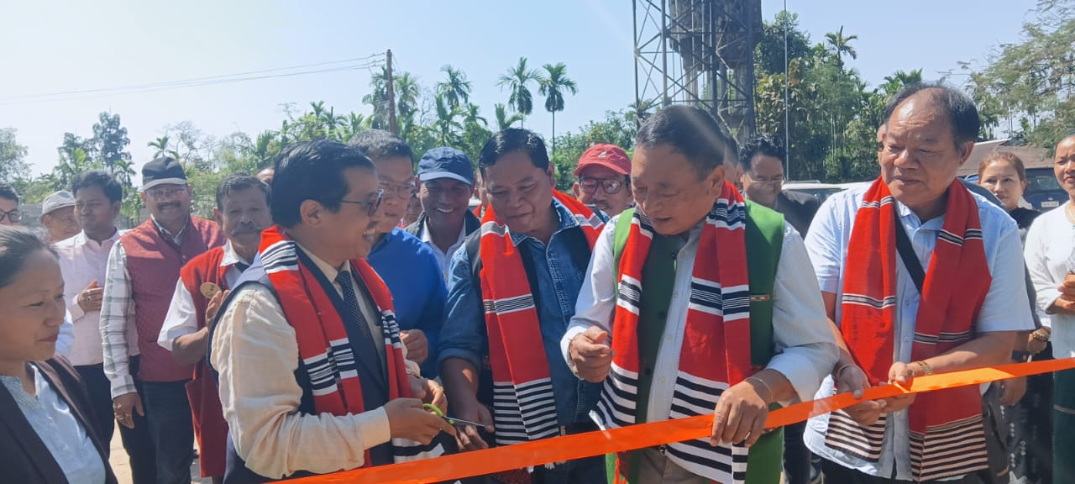

OYAN, March 25: More than 750 rural populace of Sille-Oyan Circle have immensely benefitted from various Govt. services from 25 Govt. departments including SBI, APRB, AP Apex bank at Oyan today.

Local MLA Ninong Ering& DC Tayi Taggu inaugurated the Seva Aapke Dwar 2.0 Camp at Ligang Dere,Oyan Village under Sille-Oyan Circle in the presence of ZPM Bimol Lego, HoDs, LDM P.Basumatary,CO Sille-Oyan, Dubom Apang ,Nodal Officer, Tatak Mibang, HGB Jotin Bori, GBs, PRI members.

Ering also handed over Soil Health Cards availed by more than 150 rural progressive farmers of Sille-Oyan, which will help in scientific soil testing for sustainable farming. He termed the State Government’s initiative to bring essential govt. services of various departments at the doorstep of the people as a laudable last mile service to reach the last man on the line,particularly the needy rural people. The MLA also urged the people to enroll under CMAAY& Ayushman Bharat (PM-JAY) Health coverage which will help a lot in bearing medical expenses for treatment and asked for creating maximum awarenessof on CMAAY, PM-JAY &various Central and State flagship schemes to the grassroot people. Ering also interacted with the beneficiaries and HoDs and took their feedbacks on the services extended at the Oyan SAKD Camp.

DC Tayi Taggu also expressed his satisfaction with the large turnout of rural beneficiaries at the SAKD to avail various essential Govt. services.
