GOVERNOR’S SECRETARIAT
ARUNACHAL PRADESH
ITANAGAR

Press Communiqué
Dated Mar 25th, 2025

Governor flags of Motorcycle Expedition
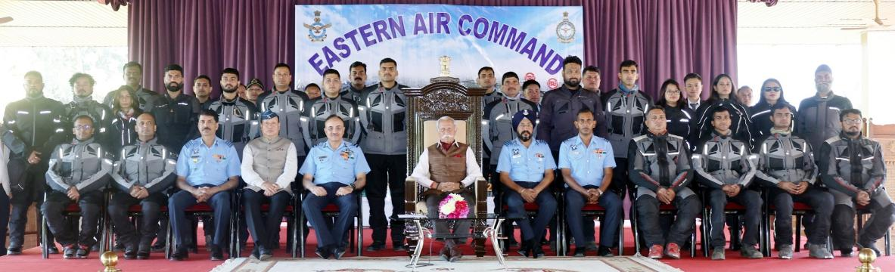

- The Motorcycle Expedition will promote adventure and also showcases Arunachal Pradesh’s rich tourism potential, including eco, adventure, cultural, and rural tourism: Governor
- Governor advises the expedition team to engage with local youth and students along their journey, encouraging them to consider careers in the Armed Forces
The Governor of Arunachal Pradesh Lt. General KT Parnaik, PVSM, UYSM, YSM (Retd.) flagged off the Motorcycle Expedition, ‘Wings and wheels Glorious IAF and magnificent North East’ from Raj Bhavan, Itanagar on 25th March 2025. Organized by the Eastern Air Command, Shillong, the twelve-day expedition aims to inspire the youth of the North East to join the Armed Forces.
Complimenting the Eastern Air Command for this initiative, the Governor highlighted that the expedition will promote adventure and also showcases Arunachal Pradesh’s rich tourism potential, including eco, adventure, cultural, and rural tourism.
The Governor advised the expedition team to engage with local youth and students along their journey, encouraging them to consider careers in the Armed Forces. He also suggested incorporating audio-visual presentations on the Indian Air Force’s operations to further inspire young minds.
Interacting with the participants, the Governor emphasized Arunachal Pradesh’s rapid development, driven by Prime Minister Shri Narendra Modi’s vision of Viksit Bharat. He noted significant advancements in infrastructure, including roads, mobile connectivity, and tourism, which are propelling the state towards prosperity.
Highlighting the State’s diverse cultural heritage, the Governor said that Arunachal Pradesh, home to numerous indigenous tribes, is blessed with a pristine natural environment and abundant resources. With focused support from the Central Government, the state is on a path of sustainable growth.
Air Vice Marshal HA Rather, VM, Air Commodore Tarun Desai, VSM and Air Commodore and Air Commodore R.D. Mosabi (Retd.), Director cum Secretary, Rajya Sainik Board, Arunachal Pradesh were during the flag off ceremony amongst others.
The expedition, which began in Bagdogra on 18th March 2025, is led by Group Captain Avinash Bhardwaj. It features 27 motorcycles and a team of 15 Air Force personnel and 12 Royal Enfield riders. Having covered 2,880 km so far, the expedition will proceed to Pasighat, Ziro, Jorhat, Diphu, and Shillong in the coming days.

