GOVERNOR’S SECRETARIAT
ARUNACHAL PRADESH
ITANAGAR

Press Communiqué
Dated Mar 23rd, 2025

SFS College Organizes District level VBYP 2025
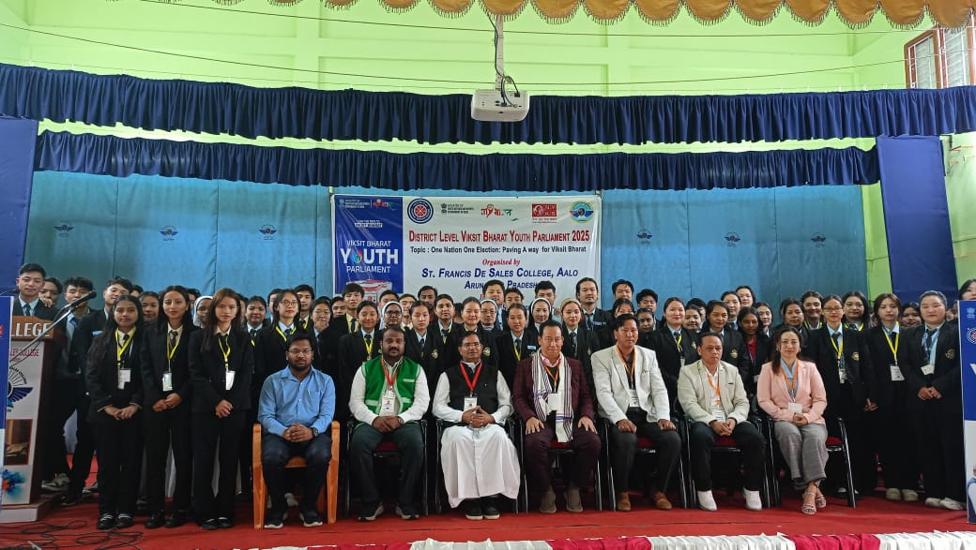

Aalo the 23rd March 2025: Saint Francis De Sales College, Aalo, in association with the NSS Unit SFSC and NYKS Aalo, organized the District Nodal Round of the Viksit Bharat Youth Parliament (VBYP) 2025 on the topic “One Nation, One Election: Paving the Way for Viksit Bharat” on March 22-23, 2025, in the Mermier Auditorium of the college.
SFS College, Aalo, is the district nodal institute for the youths of West Siang, LepaRada, Shi-Yomi, and Upper Subansiri districts. The VBYP 2025 was organized as per the directions of the Regional Directorate of National Service Scheme (NSS), Guwahati, under the Ministry of Youth Affairs and Sports, Government of India.
The mega event was conducted under the chairmanship of Dr. Fr. Jose Karipadathu, Principal, and was well-coordinated by Mr. Kenli Ete, NSS Program Officer cum Nodal Officer VBYP 2025, along with Ms Inkey Tayeng, IQAC Coordinator, SFS College and Mr. Moji Riba, the In-charge of the Literary Club.
The inaugural ceremony was graced by the young and dynamic youth leader Adv. Topin Ete, MLA of the 30-Aalo West Assembly Constituency. In his inaugural message to the youth, he emphasized the importance of positive youth participation and appealed to the young generation to stay away from drugs. The Principal of SFS College cum chairman delivered the welcome address, underscoring the significance of youth involvement in shaping the nation’s future.
During the two-day event, 105 participants actively presented three-minute speeches on the given topic, showcasing their insights and perspectives. The selected 10 participants would represent Nodal District in the state capital Itanagar, Arunachal Pradesh.
The Viksit Bharat Youth Parliament serves as a cornerstone for empowering young voices, fostering a spirit of responsibility, and inspiring future leaders to contribute to the nation’s progress.

