GOVERNOR’S SECRETARIAT
ARUNACHAL PRADESH
ITANAGAR

Press Communiqué

Dated Mar 23rd, 2025

Borderland Narratives 2025 Concludes At RGU; Filmmakers Urge a Network For Regional Stories.
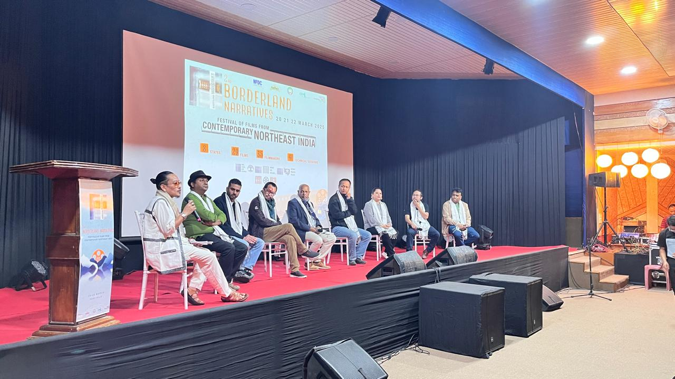

23 March, Rono Hills: The three-day 2nd edition of Borderland Narratives: Festival of Films from Contemporary North East India culminated successfully at the RGU campus on Saturday, with the Award Ceremony for the Short Film Competition. The festival brought together filmmakers, film enthusiasts, and cultural aficionados from across the North East, and witnessed an array of thought-provoking feature, documentary and short films that highlighted the rich tapestry of stories, experiences, and cultures of the region. The 1st edition of the festival was held in 2019.

In his closing remarks, Vice Chancellor (i/c) of the University, Prof. S.K. Nayak called for the festival to be scaled up and also held at New Delhi so that a larger audience could experience films from the region and extended his support in mobilizing funds. Congratulating the Department of Mass Communication and the Arunachal Institute of Tribal Studies (AITS) for spearheading the festival, he also acknowledged the Centre for Cultural Research and Documentation (CCRD) and the Research Institute of World's Ancient Traditions, Cultures and Heritage (RIWATCH) Roing for their collaborative inputs. He commended the visiting filmmakers for their dedication in fostering storytelling and developing a rich film culture.

Earlier in the festival, participants witnessed an interactive master class on editing by national award-winning editor Sanjiv Monga, on screenplay writing by Alka Singh, Associate Professor at the Film and Television Institute, Jote and on Funding for Independent Film, conducted by Alexander Leo Pou, Director of Manipur State Film and Television Institute, Imphal, who encouraged young filmmakers to start with simple resources like mobile phones and begin storytelling with relatable elements like Arunachal's mountains and rising sun. He also stressed the importance of a well-developed screenplay, script duration, potential actors, and creating a portfolio for investors and recommended including images, audio, and visuals to enhance project presentations and highlighted that the National Film Development Corporation (NFDC) as one of India’s largest funding agencies for films, was a good source of support.

A highlight of the concluding day was the enriching panel discussion on networking and synergy of filmmakers from the region. Moderated by Festival Director Moji Riba, it had filmmaker representatives from eight states of the region as panelists who engaged in an engrossing discussion on the diverse challenges and opportunities surrounding filmmaking and cinema in the Northeast. The conversation explored key issues such as financial constraints, limited distribution networks, lack of institutional support, and the dominance of mainstream languages that often overshadow regional and tribal cinema. At the same time, the panel highlighted emerging opportunities, including digital platforms, community-driven initiatives, film festivals, and called for a collaborative network to share regional narratives and strengthen the region’s cinematic landscape. The panel also appealed to all State governments of the region to formulate comprehensive film policies to support regional cinema.

Dr. Sunil Koijam, Festival Co-director in his festival report informed the audience that a total of 29 films were screened during the festival, along with 4 industry sessions and saw the presence of 35 filmmakers from across the country, which included internationally acclaimed filmmakers Pradip Kurbah (Meghalaya), Dominic Sangma (Meghalaya), Haobam Pawan Kumar (Manipur) and Utpal Borpujari (Assam). Introducing the festival’s closing film, he said that the festival was not just an event—it was a celebration of art, culture, storytelling, and the power of cinema to unite us all and inspire each other.

In the short film competition on the theme Vanishing Roots: Art, Culture and Folklore, Eta Laidhibi by H. Chinglemba Meitei won the best film award of rupees fifty thousand and a trophy for his empathetic rendition of a Meitei traditional doll maker’s journey as she breathes life in her dolls, that are slowly getting buried under the sands of time. The jury, comprising filmmakers Dr. Bappa Ray, Yapangaro Longkumer and Bobo Khuraijam, also commended Tune of Love by Dr. Indrakumar Moirangtham with a jury mention.

Festival Director Prof. Simon John, in his closing remarks emphasized on the power of filmmaking also as a tool for documentation and cultural preservation. He extended his gratitude to the invited filmmakers from the region for their participation and reaffirmed the need to nurture and promote northeast India’s cinematic landscape.

The 3-day festival, supported by the Govt of Arunachal Pradesh and the National Film Development Corporation (NFDC), Ministry of Information and Broadcasting, closed with a soulful performance by internationally acclaimed folk-fusion artist David Angu, whose melodies reverberated with the same spirit of the power of narratives of the north east region.
