GOVERNOR’S SECRETARIAT
ARUNACHAL PRADESH
ITANAGAR

Press Communiqué
Dated Mar 22nd, 2025

Governor Participates In The Spreadhead Seminar
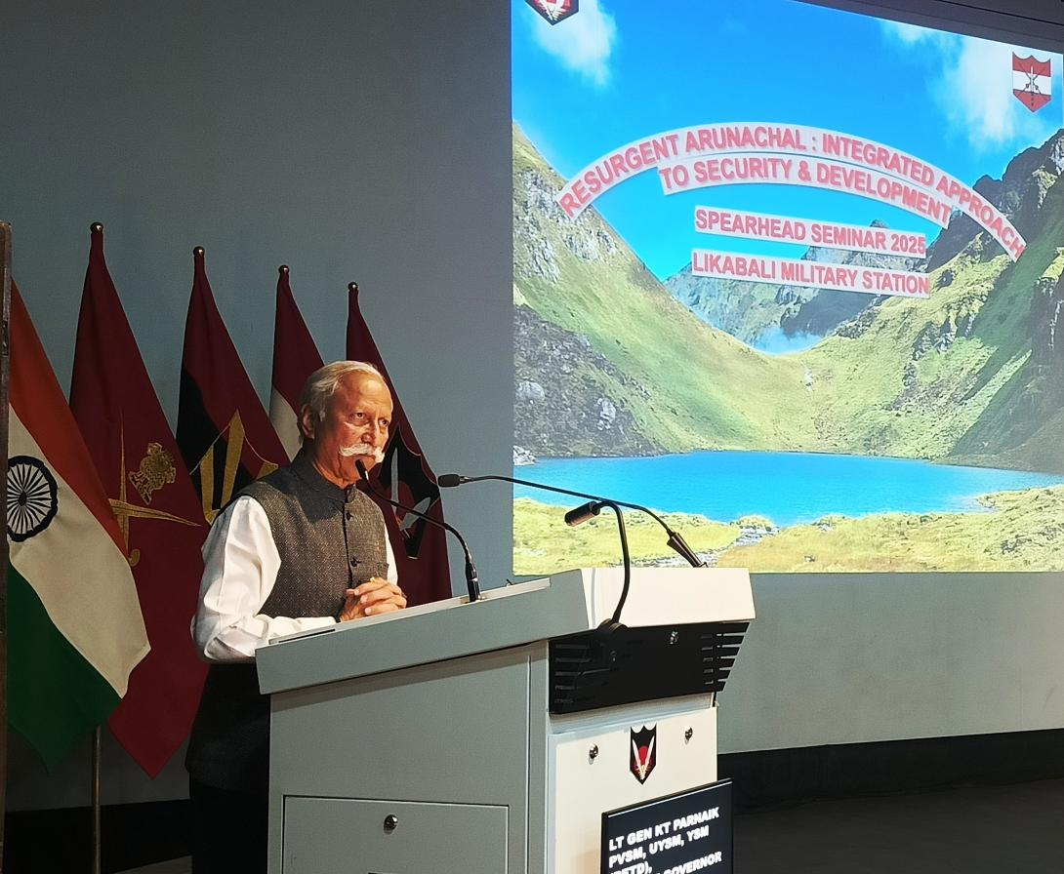

- Governor emphasizes Arunachal Pradesh’s sensitive and strategically vital border and the need for constant vigilance due to its proximity to neighboring countries
- Governor underscores the role of integrating local communities with security forces, fostering mutual trust, and adopting a collaborative approach to border safeguarding
The Governor of Arunachal Pradesh, Lt. General KT Parnaik, PVSM, UYSM, YSM (Retd.), participated in the grand finale of the two-day Biennial Seminar organized by the Spearhead Division, the 56 Infantry Division at the Military Station, Likabali on 22nd March 2025. The seminar, titled 'Resurgent Arunachal: Integrated Development and Security Approach', focused on the state’s strategic significance and socio-economic diversity.
In his address, the Governor emphasized Arunachal Pradesh’s sensitive and strategically vital border and the need for constant vigilance due to its proximity to neighboring countries. He reiterated the importance of strengthening security along the Line of Actual Control (LAC) through technological advancements and active community involvement.
Highlighting the intersection of security and development, the Governor stated that Arunachal Pradesh stands at a crucial juncture where both aspects must work in synergy to ensure a prosperous future. He underscored the role of integrating local communities with security forces, fostering mutual trust, and adopting a collaborative approach to border safeguarding.
The Governor outlined the state's vision for growth, which includes modernizing governance, improving the quality of life, and promoting inclusive and sustainable development. He stressed the significance of strengthening local administrations and encouraging community participation in decision-making to deepen democracy.
HIghlighting on the Government of India’s Vibrant Villages Programme (VVP), the Governor noted that it aims to provide essential facilities to border villages, ensuring development at the grassroots level. He stressed the need for collaborative efforts between the State administration, armed forces, and local communities to make these villages self-sufficient and vibrant.
The Governor commended Lt. Gen. Abhijit S. Pendharkar, AVSM, YSM, GOC, 3 Corps, and the 56 Infantry Division for organizing the seminar. He acknowledged the event as a crucial platform for discussing the region's history, transformation, and the strategic role of information warfare, laying the foundation for future initiatives.
The two-day seminar featured insightful discussions on various themes, including the Puranic connections, cultural interactions, ancient trade routes, the evolution of tribal society, and the transformation dynamics of Arunachal Pradesh. Key topics such as Operation Sadbhavana, crisis management, cultural sensitivity, inclusivity, and the role of media in narrative-building were also deliberated.
