GOVERNOR’S SECRETARIAT
ARUNACHAL PRADESH
ITANAGAR

Press Communiqué

Dated Mar 22nd, 2025

ICAR-NRCY, Dirang Celebrates World Water Day 2025 with Tribal Farmers of Tawang
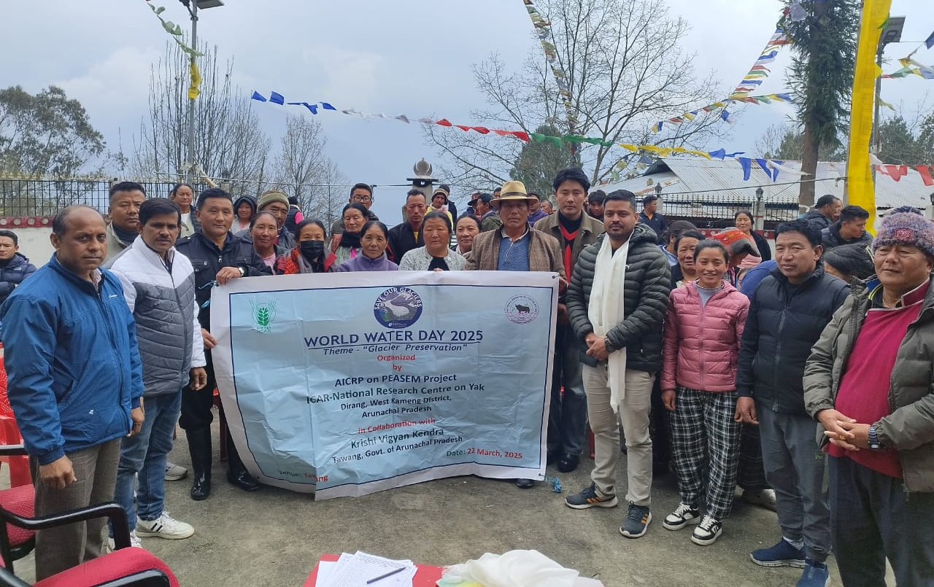

Tawang, 22 March 2025 – The ICAR-National Research Centre on Yak (ICAR-NRCY), Dirang, in collaboration with Krishi Vigyan Kendra (KVK), Tawang, successfully organized an awareness program on the scientific rearing of highland animals to commemorate World Water Day 2025. The event, held in the Lembardung area, saw the participation of 100 tribal livestock farmers from various villages across the region.
The program commenced with a welcome address by Dr. C. K. Singh, Subject Matter Specialist, KVK, Tawang. He emphasized the importance of adopting scientific practices in highland livestock management and encouraged farmers to collaborate with research institutes for enhanced productivity and economic benefits.
Dr. D. Medhi, Principal Scientist, ICAR-NRCY, Dirang, provided valuable insights into advanced feeding and breeding techniques aimed at improving the productivity of highland animals. He also highlighted the significance of maintaining hygiene in milk production, value addition of livestock products, and essential healthcare practices, particularly during the harsh winter months.
Further, Dr. Ninad Bhatt, Senior Technical Officer, ICAR-NRCY, Dirang, elaborated on reproductive and health management strategies for highland livestock. He urged farmers to adopt modern technologies developed by ICAR-NRCY to improve economic returns and ensure livelihood security. Dr. C. K. Singh also encouraged the establishment of a value chain for yak and yak-cattle hybrid products, alongside exploring marketing opportunities to enhance the profitability of yak husbandry.
A key highlight of the event was the emphasis on World Water Day’s theme, which underscored the importance of glacier preservation, forest conservation, and the judicious use of water resources to sustain livestock farming in high-altitude regions.
As part of the initiative, participating farmers were provided with essential supplies, including concentrate yak feed, gumboots, tarpaulin, mineral mixtures, and veterinary supplies such as common salt, anthelmintics, anti-diarrheal medicines, and tick repellents. These provisions were distributed under the Northeast Hill (NEH) component of ICAR-DPR, Hyderabad, and the Scheduled Tribe Component (STC) initiative of ICAR-CIRB, Hisar.
The participating farmers and officials expressed their sincere appreciation for the leadership and support extended by Dr. Mihir Sarkar, Director, ICAR-NRC on Yak, in facilitating these benefits for the tribal farming community.
This initiative underscores ICAR-NRCY’s commitment to sustainable livestock development in Arunachal Pradesh’s high-altitude regions, ensuring improved productivity, economic empowerment, and water conservation. The organization remains dedicated to advancing scientific livestock management practices for the benefit of tribal farmers and the broader agricultural community.
