GOVERNOR’S SECRETARIAT
ARUNACHAL PRADESH
ITANAGAR

Press Communiqué

Dated Mar 22nd, 2025

Indian Army Hosts Seminar on ‘Resurgent Arunachal: Integrated Approach to Security and Development’ at Likabali
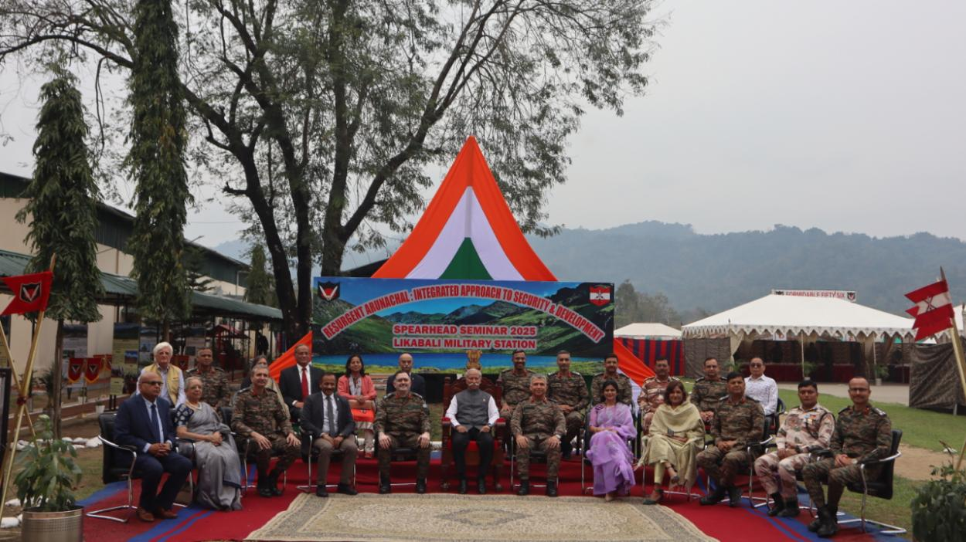

Likabali, Arunachal Pradesh – The Indian Army organized a Strategic Seminar on ‘Resurgent Arunachal: Integrated Approach to Security and Development’ at Likabali Military Station, bringing together senior military officials, policymakers, academicians, and local dignitaries to deliberate on Arunachal Pradesh’s strategic importance, development trajectory, and evolving security landscape.
The event was graced by Lt Gen KT Parnaik, PVSM, UYSM, YSM (Retd), the Hon’ble Governor of Arunachal Pradesh, whose presence added immense value to the discussions. The seminar also saw enthusiastic participation of young minds from local colleges, Indo Tibet Border Police and Civil Administration fostering a collaborative exchange of ideas on the region’s future.
The seminar was structured around three important themes—‘Arunachal Through the Prism of History,’ ‘Arunachal Transformation: Trajectory of Development,’ and ‘Leveraging Information Warfare: Navigating the New Frontier.’ Experts underscored Arunachal Pradesh’s historical significance in shaping India’s frontier policies, the region’s impressive infrastructural and socio-economic advancements, and the growing impact of information warfare on national security.
Senior military officers emphasised the need for a synergized civil-military approach to ensure balanced development while addressing security concerns. Scholars and policymakers highlighted how infrastructure projects, improved connectivity and government initiatives have significantly contributed to the state’s transformation. The discussions also explored challenges posed by misinformation and cyber threats, stressing the importance of robust information warfare strategies.
The seminar reaffirmed the collective commitment of all stakeholders to an integrated strategy, reinforcing Arunachal Pradesh’s role in India’s security and development framework. The active engagement of the Hon’ble Governor, Lt Gen KT Parnaik, PVSM, UYSM, YSM (Retd) and local youth in the discussions underscored the region’s growing significance and the need for a holistic, future-ready approach.
There were numerous recommendations for the policy makers and best practices which were highlighted during the seminar, for all relevant stakeholders to implement in their domain.

