GOVERNOR’S SECRETARIAT
ARUNACHAL PRADESH
ITANAGAR

Press Communiqué
Dated Feb 9th, 2025

Second Edition of Bharat Lok Sangeet – Arunachal Utsav 2025 Showcases Rich Folk Traditions and Cross-Cultural Exchange
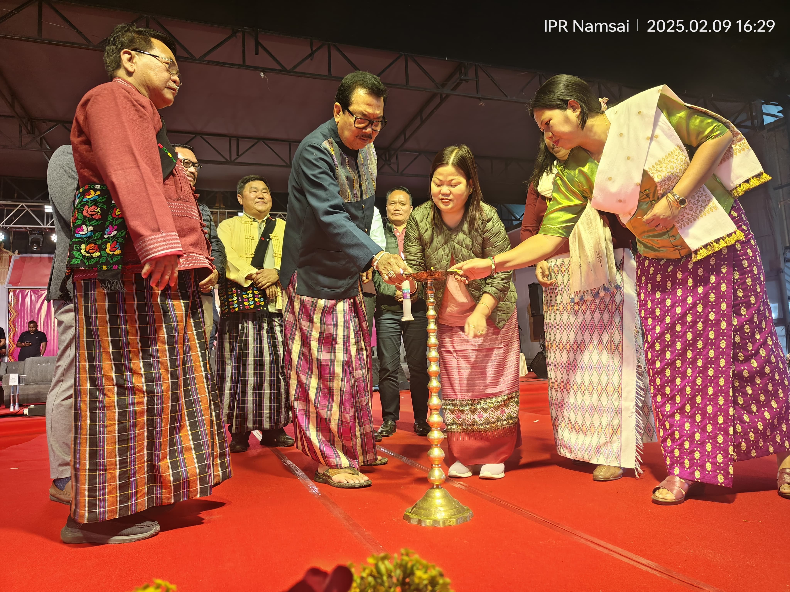
Namsai, 09.02.2025 : The vibrant cultural essence of Arunachal Pradesh took center stage as the Second Edition of Bharat Lok Sangeet – Arunachal Utsav 2025 commenced at Poi Pee Mau Tai Ground, Namsai. Organized by the Government of Arunachal Pradesh under the aegis of Ek Bharat Shreshtha Bharat, this festival is a tribute to India’s rich folk traditions, serving as a confluence of art, heritage, and cultural exchange. By bringing together artists from across the country and beyond, the festival has evolved into a powerful platform for fostering deeper cultural ties and strengthening Arunachal Pradesh’s identity as a guardian of indigenous heritage.
The opening ceremony of the 2nd Edition was graced by Shri Wangki Lowang, Hon’ble Minister of Environment, Forest & Climate change, Geology, Mining & Minerals and DoTCL as the Chief guest, Smt Dasanglu Pul, Hon’ble Minister (WCD and Science & Technology) as Guest of Honor, the chief patron, Hon’ble DCM Shri Chowna Mein, Hon’ble Minister (Agriculture, Horticulture, Animal Husbandry & Veterinary, Fisheries and Food & Civil Supply), HMLA-cum-Advisor Dr. Mohesh Chai, Smt Chakat Aboh, Shri Mutchu Mithi, Shri Mopi Mihu, Chau Zingnu Namchoom, HMLAs Shri Oken Tayeng, Shri Nikh Kamin, Smt Nyabi Dirchi, Shri Puinnyo Apum, Shri Likha Soni and host of distinguished dignitaries.
This year, the festival features 15 cultural troupes from Arunachal Pradesh : Igu Priest Dance from Lower Dibang Valley, Pakhu Itu Apatani Folk Dance from Lower Subansiri, Memba Folk Dance from Shi Yomi, TIPA Dance from Lohit, Aka Hrusso from West Kameng, Sartang from West Kameng, Tapu Dance from Siang, Buya Folk Dance from Kurung Kumey, Bedu Folk Dance from Lohit, Juju Jaja Folk Dance from Keyi Panyor, Nyida Parik Folk Dance from Leparada, Ollo Dance from Tirap, Moh Mol Folk Dance from Changlang, Snow Lion Dance from Tawang and Peacock and Golden Deer Dance from Namsai. Additionally, cultural groups from Himachal Pradesh, Karnataka, and Manipur have joined the festival, ensuring a rich blend of regional traditions. With the participation of international performers from Bhutan, this edition marks a significant milestone in strengthening cross-cultural exchanges, reinforcing the message that folk traditions are universal, transcending borders and generations. The three days event will also feature performances from artists Mame Khan, Nizami Bandhu, Guru Rewben, Dobom Doji and Delong Padung & Band. \
