GOVERNOR’S SECRETARIAT
ARUNACHAL PRADESH
ITANAGAR

Press Communiqué
Dated Feb 8th, 2025

The Arunachal Film Festival (AFF) 2025 concluded on Saturday
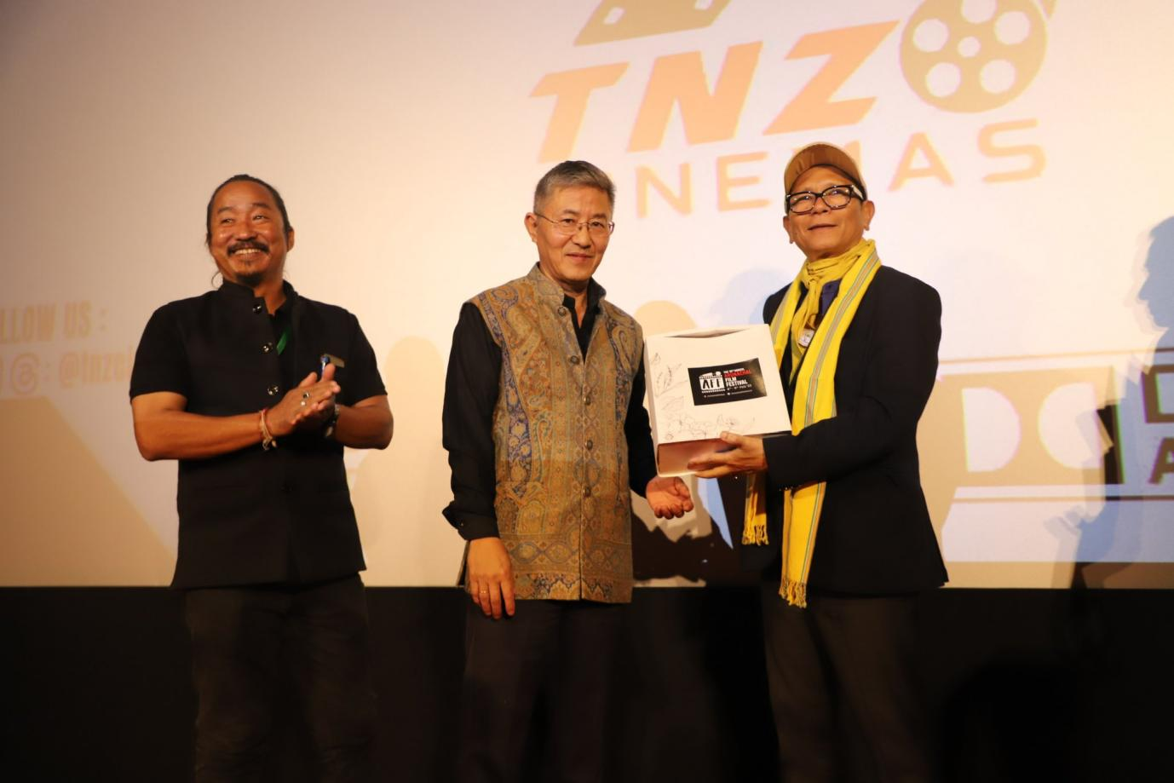

The Arunachal Film Festival (AFF) 2025 concluded on Saturday after a vibrant three-day celebration of cinema, creativity, and emerging talent in the state. The festival, which commenced on February 6, provided a significant platform to showcase the evolving film industry in Arunachal, with a particular focus on local filmmakers, technical expertise, and animation talent.
Information and Public Relations minister Nyato Dukam who graced the valecditory event as chief guest commended the Department of Information and Public Relations (IPR) for successfully organizing the festival. He also lauded the perseverance and creativity of filmmakers despite the challenges they face. “The film industry in Arunachal Pradesh is still in its early stages, but the future is bright,” Dukam said. He noted that the lack of a common language remains a challenge in reaching wider audiences and urged the IPR department to devise solutions to strengthen the state’s film industry.
The minister also announced that the Film and Technical Institute of Arunachal Pradesh would soon be commissioned to provide essential training for aspiring filmmakers, photographers, and technical professionals. He emphasized the need for collective efforts to address logistical challenges such as funding and distribution, which are crucial for elevating the state’s cinema industry.
IPR secretary Nayli Ete echoed these sentiments, describing the festival’s success as a testament to the growing interest in filmmaking in Arunachal.
He highlighted the department’s ongoing initiatives, including the AVGC-XR policy introduced by the Ministry of Information and Broadcasting, aimed at supporting budding filmmakers.
Ete acknowledged the financial and technical constraints faced by filmmakers and stressed the importance of building a sustainable ecosystem for the industry. He assured that the IPR department remains committed to providing platforms like AFF to nurture talent and foster growth.
The festival’s final day was marked by screenings, workshops, and interactive sessions. Notable documentaries, including Grandpa What’s Your Name, Khew Ranei, and Seeds of the Future, offered audiences a powerful glimpse into real-life stories. In the short film category, standout entries such as Mok Mu, Changes, and When Will the Moon Bloom Again? captivated viewers with their compelling narratives. A special session titled “In Conversation with Chum” saw the acclaimed actress share her journey from Northeast India to Bollywood, inspiring aspiring filmmakers with her experiences. Two workshops also garnered significant participation.
Raktim Modol, a professor at the Film and Television Institute of India (FTII), led a session on The Art of Cinematography, delving into the nuances of lighting, composition, and visual storytelling across different film genres.

Vinod VS from Toon Media Group conducted a workshop on Animation Filmmaking: From Script to Screen, guiding attendees through the process of conceptualization, storyboarding, 3D modeling, and character design.
As the festival concluded, awards were presented to outstanding films.
Grandpa What’s Your Name, directed by Lonsang Phuntso, won Best Documentary, while Our Land Our Lives by T Hasa received a Special Mention Award. In the short film category, Mok Mu, directed by Chau Anandra Namchoom, was named Best Short Film, while Change, produced by Down Mountain Studio, earned a Special Mention Award. AFF 2025 nodal officer Dugyir Padu delivered the vote of thanks, acknowledging the contributions of participants, volunteers, and attendees who made the event a success.
The Arunachal Film Festival 2025 reinforced the state’s commitment to nurturing its film industry, celebrating creativity, and paving the way for future filmmakers to make a mark on the national and global stage.

