GOVERNOR’S SECRETARIAT
ARUNACHAL PRADESH
ITANAGAR

Press Communiqué
Dated Feb 8th, 2025

Agriculture Minister Wangsu review ongoing schemes
& interact with progressive farmers
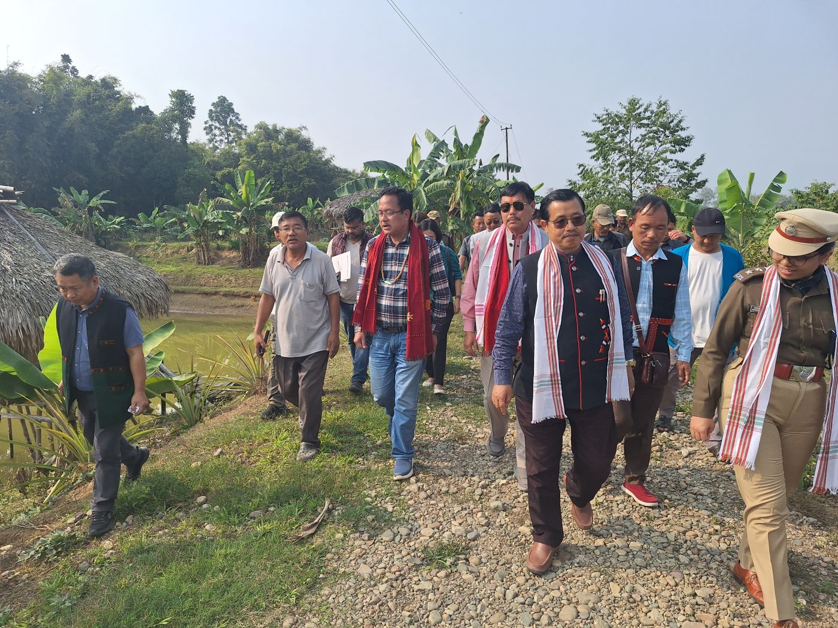

PASIGHAT, Feb 08: Minister for Agriculture, Horticulture , Animal Husbandry & Vety. Fisheries, etc , Gabriel D Wangsu who is on his maiden visit to East Siang , today inspected t slew of agri and allied projects implemented in the district and also interacted with the beneficiary farmers during his field visits to farms of progressive farmers. The Minister stressed that successful implementation of various agri and allied schemes will motivate more farmers as a viable economic activity. Later ,The Minister also took stock of the status of ongoing schemes during a review meeting at Siang guest House with HoDS in the presence of MLA Tapi Darang & DC Tayi Taggu.
The Minister was accompanied by MLA Tapi Darang, DC , Tayi Taggu, SDPO, Akanksha M Tamgadge, DAO Opang Moyong, DHO Airemi Ering, DAHVO , Dr. Obang Siram, DFDO Incharge cum Fishery Officer Kabang Komut, DFCSO B.Pertin , EE WRD 0 .Panyang and officials
Another highlight of his visit was to floral village ( Bodak) under Mebo sub division where in the Minister lauded the Mission Pun: lek (floral village destination ) initiated by the local MLA Oken Tayeng . The Minister urged the community to avail schemes to take up floriculture as an economic activity in tune with the innovative floral mission. Local MLA Oken Tayeng, DC Tayi Taggu and ADC Mebo Sibo Passing, HoDS were present on the occasion at Bodak.
The Minister who also holds the charge of Food & Civil Supplies, also visited the civil supplies & District Agriculture Store ,Pasighat,
During his visit , the Agri Minister inspected the IDDP & ANE Diary Plant at VTI, Govt. Piggery Farm at 7 mile, Pane Korong Fish farm & Fishery Office, , DAO office , DHO Office at GTC , District Veterinary Hospital and the liquid Nitrogen Plant , Nursery & Spawn Production Centre at DHO Office, Oil Palm Plantation and Dargon fruit cultivation of progressive farmer, Miti Megu at 4 Mile , Fish Pond of progressive farmer Besing Tatin at Gobo .
The Minister also said that the integrated farming taken up by progressive farmer Megu & Tatin should also inspire and model success stories in integrated farming.
The Minister during his visit to fish pond of progressive farmer Sri Besing Tatin of Rani Village taken up under PMMSY Scheme in 2021-22 was apprised that Tatin has successfully done Integrated Farming of Fish Cum Duckery Culture alongwith Horticulture Crops like Banana, Pineapple etc around the embankment of Fish Ponds.
The Minister was apprised for Carp Fish Hatchery (Private) to fulfill the demand of quality fish seeds in East Siang district. It was also requested to increase the allotment of Fish Ponds under Atma Nirbhar Matsya Palan Yojana scheme for potential pisciculture District like East Siang.
The Minister also stressed on renovation of existing infrastructure in Veterinary Training Institute (VTI) for implementing the Govt. of AP budget Announcement for training of unemployed youth in animal husbandry & poultry under its “ Catch them Young “ Scheme Initiative.
For the functioning of Ane dairy Plant at VTI , Wangsu called for revival of dairy cooperative societies (DCS) in East Siang to tap the dairy sector for economic empowerement of dairy farmers.
