GOVERNOR’S SECRETARIAT
ARUNACHAL PRADESH
ITANAGAR

Press Communiqué
Dated Feb 7th, 2025

Government of Arunachal Pradesh Signs MoU with Adhyayan Quality Education Foundation to Strengthen School Ecosystem
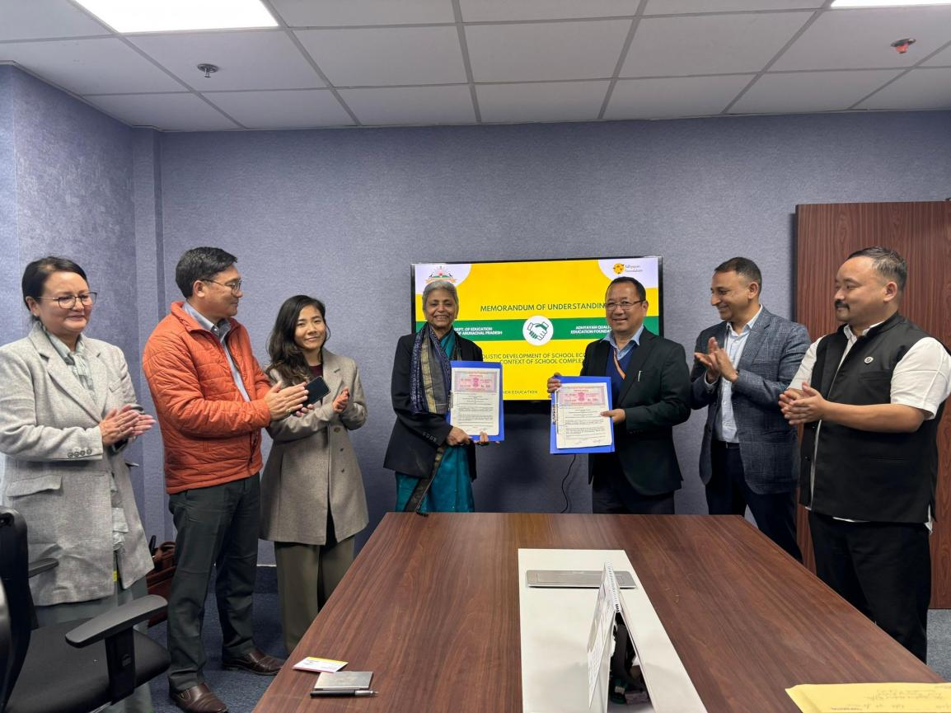
Itanagar, 7th February 2025 – In a significant move to enhance the education landscape of Arunachal Pradesh, the Department of Education, Government of Arunachal Pradesh, has signed a Memorandum of Understanding (MoU) with Adhyayan Quality Education Foundation. This partnership is aimed at fostering the holistic development of the school ecosystem, with a special emphasis on strengthening school complexes.
The signing ceremony was attended by several key dignitaries, including Commissioner of Education Shri Amjad Tak, Secretary of Education Shri Duly Kamduk, Joint Secretary Smt. Namgyal Angmo, Director SCERT Shri Toko Babu, OSD to the Education Minister Shri Pema Norbu Thongchi, Deputy Director SCERT Smt. Drema Ringu, and Director of Adhyayan Quality Education Foundation Smt. Manju Gupta. Their presence underscored the government’s unwavering commitment to improving educational outcomes through strategic collaborations.
This partnership aims to elevate the quality of education by enhancing teacher pedagogy, fostering community engagement, strengthening leadership and governance, and activating school complexes as vibrant learning hubs. Through a structured and systemic approach, the initiative seeks to transform schools into centers of academic excellence while also ensuring holistic student development.
Speaking on the occasion, Commissioner of Education Shri Amjad Tak highlighted the significance of structured interventions in building a robust school ecosystem. “This MoU marks a crucial milestone in our mission to uplift the quality of education in Arunachal Pradesh. Strengthening school complexes will enable shared resources, peer learning, and improved teacher support, ultimately benefiting students across the state,” he stated.
The Government of Arunachal Pradesh remains committed to fostering meaningful partnerships that drive educational transformation, ensuring that students receive quality education in an environment that nurtures their overall growth and development.

