GOVERNOR’S SECRETARIAT
ARUNACHAL PRADESH
ITANAGAR

Press Communiqué
Dated Feb 6th, 2025

Two-Day Training for GDMOs of TCL on Postmortem Examination and Other Medico-Legal Issues
at General Hospital, Khonsa
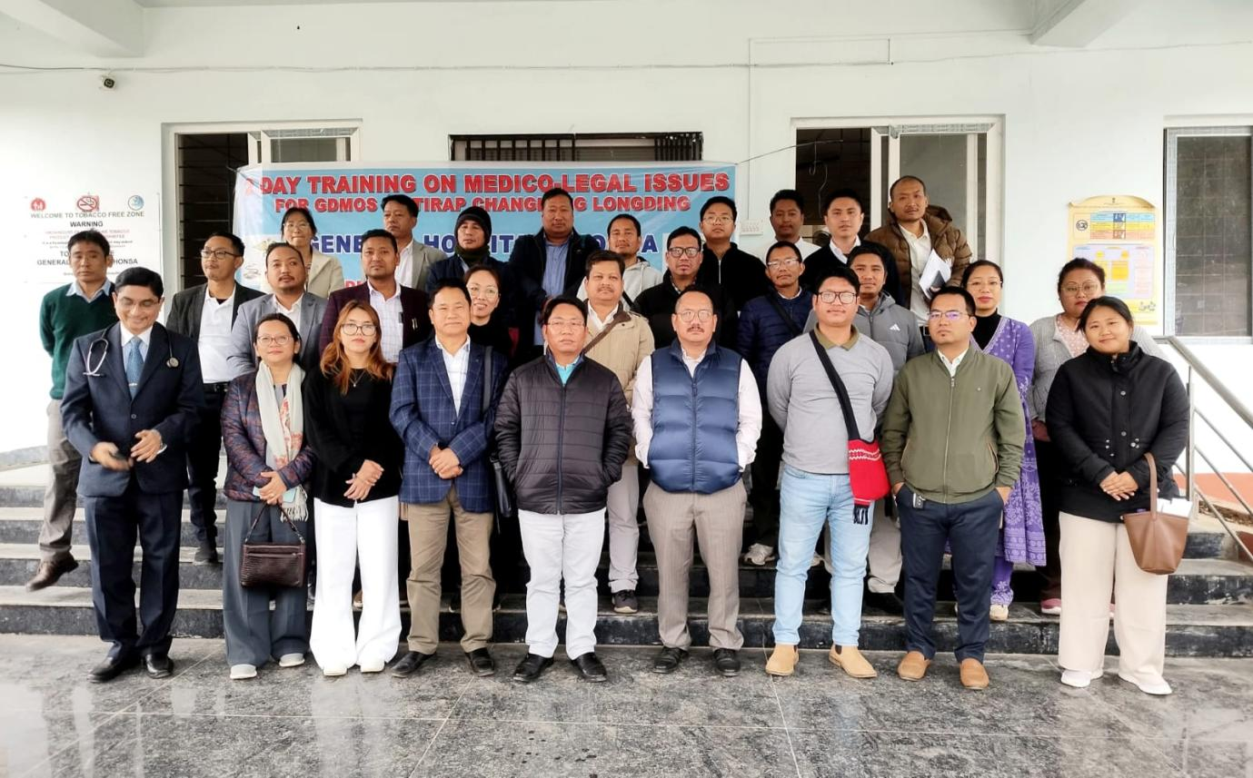

Khonsa, 6th February 2025: A specialized training program for General Duty Medical Officers (GDMOs) of Tirap, Changlang, and Longding (TCL) was successfully conducted on 4th and 5th February 2025 at General Hospital, Khonsa. The training was organized in collaboration with the Directorate of Medical Education (Training & Research) and Forensic Sciences, TRIHMS Naharlagun, Government of Arunachal Pradesh. A total of 40 doctors from across TCL attended this important session.
Dr. N. Lowang, District Medical Officer (DMO), extended a warm welcome to the esteemed resource persons, Dr. Techi Rekhi, Forensic Specialist, TRIHMS, and Dr. Mope Loyi, Forensic Specialist from BPGH, Pasighat. She also welcomed the participating doctors from various health facilities in Tirap, Changlang, and Longding, acknowledging their dedication to improving medico-legal expertise.
Key Topics Covered:
- Case Work Test on Postmortem Examination (PME) Report Writing
- Approach to PME Cases
- Medico-Legal Examination of Sexual Assault Cases
- Demonstration on the Use of Sexual Assault Forensic Examination Kit (SAFE Kit)
- Relevant Medico-Legal Sections of BNS, BNSS, and BSA
- Medico-Legal Duties of Doctors at Casualty
- Orientation and Advocacy on Medico-Legal Examination and Postmortem Reporting (MedLeaPR)
Review Test and Open Discussion with Trainees
The training was highly interactive and insightful, marking a significant step in enhancing the technical capabilities and efficiency of doctors in handling postmortem and medico-legal cases. It was the first of its kind in the region and is expected to significantly improve the medico-legal preparedness of healthcare professionals.

Going forward, review meetings and workshops for doctors of TCL will be held regularly at General Hospital, Khonsa, to further strengthen their medico-legal knowledge and skills.
The two-day training session concluded with a Valedictory Function, where Dr. Tumli Basar, Medical Superintendent, General Hospital, Khonsa, extended his heartfelt gratitude to all participants for their active involvement. He expressed special appreciation to the resource persons, Dr. Techi Rekhi and Dr. Mope Loyi, for their invaluable contributions. He also acknowledged the efforts of Dr. Thenyak Matey, SMO (SG) and Convener (Training), for meticulously organizing the event and ensuring its success. This training initiative represents a significant milestone in the continual professional development of medical officers in TCL and underscores the commitment of the Government of Arunachal Pradesh to enhancing medico-legal standards in the state.
