GOVERNOR’S SECRETARIAT
ARUNACHAL PRADESH
ITANAGAR

Press Communiqué

Dated Feb 5th, 2025

Minister Dasanglu Pul Emphasizes Meyor Cultural Identity
at Lha Chhut Festival
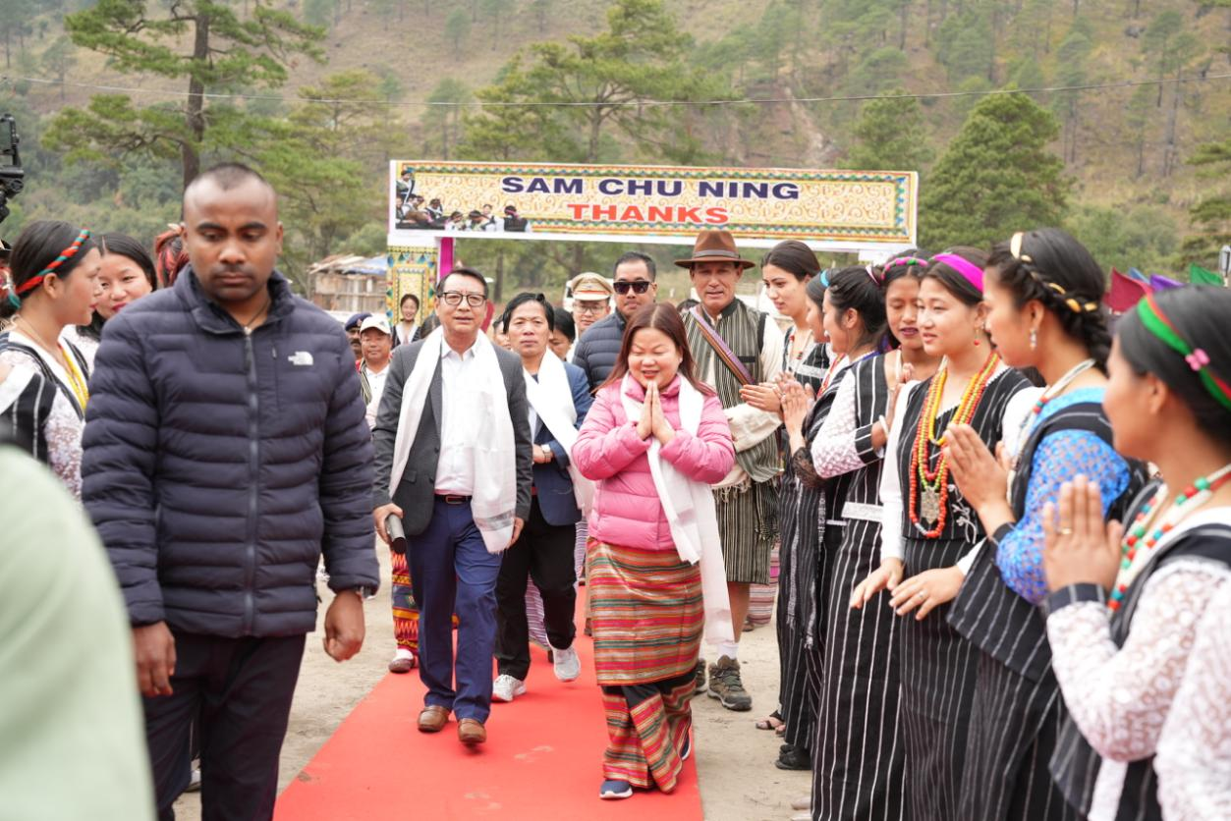

Walong: Cultural Affairs Minister Dasanglu Pul on Wednesday emphasized the need to preserve and promote the cultural identity of the Meyor community while attending the 17th Lha Chhut Festival at Tinai in Walong circle, Anjaw district.
Addressing a large gathering, Pul said, “The Lha Chhut Festival is an important occasion that reflects the rich traditions and spiritual values of the Meyor community. It is our collective responsibility to safeguard and pass these traditions to future generations.” The minister also underlined the importance of environmental conservation, particularly in protecting the region’s pine forests.
“Preserving the natural beauty of our landscape is crucial not only for ecological balance but also to sustain tourism in this picturesque region,” she said.
As part of the festival, Pul launched six pictorial glossaries on the Meyor language under the theme “Let Us Learn Meyor”, aimed at linguistic preservation. She also unveiled a documentary film on the festival, produced by the Department of Indigenous Affairs, highlighting the significance of the event.
The festival, marked by traditional dances, rituals, and community feasts, was attended by several dignitaries, including Indigenous Affairs director Sokhep Kri, Anjaw Zilla Parishad Chairperson Soblem Pul, Anjaw Deputy Commissioner Millo Kojin, Superintendent of Police Rike Kamsi and Zilla Parishad Members Anjoy Ama and Dangseplu Pul, along with heads of various departments and officials.
Indigenous Affairs director Sokhep Kri commended the Meyor community’s commitment to cultural preservation. “Festivals like Lha Chhut play a crucial role in keeping our traditions alive and fostering a sense of pride among younger generations,” he said.
The Lha Chhut Festival, celebrated annually, continues to be a symbol of unity, spiritual devotion, and cultural heritage for the Meyor community.
