GOVERNOR’S SECRETARIAT
ARUNACHAL PRADESH
ITANAGAR

Press Communiqué
Dated Feb 4th, 2025

DC reviews ongoing State and Central schemes at Monthly DLMC
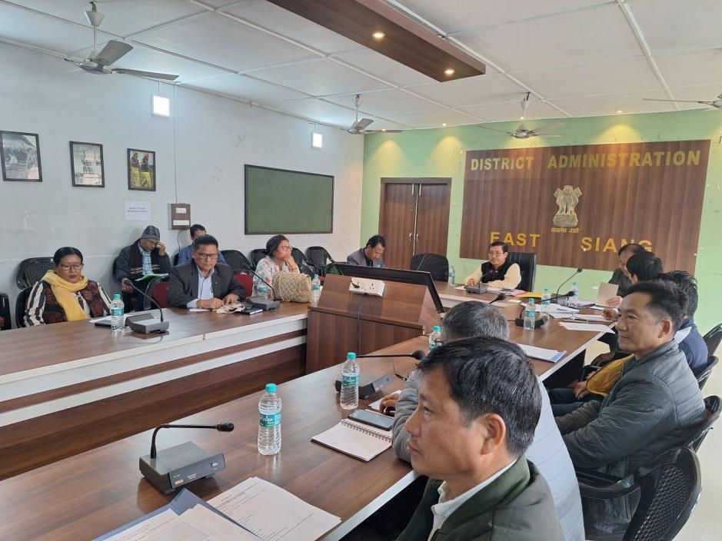

PASIGHAT, February 4: East Siang DC Tayi Taggu today reviewed the progress of various ongoing state and centrally sponsored schemes implemented by government departments, PMC, and the Smart City Mission during the monthly District Level Monitoring Committee (DLMC) meeting at the DC’s Conference Hall. He emphasized the need for inter-department coordination to ensure the smooth and successful execution of development projects. The DC also urged the Heads of Departments (HoDs) to propose innovative project ideas for the upcoming Budget 2025-26.
Among the key projects reviewed were the upgradation of Bakin Pertin General Hospital to a 300-bed facility, augmentation of the water supply for Pasighat township, Vatsalaya Sadan, Pasighat Solid Waste Management, and infrastructure works at Arunachal University. The DC also took stock of the status of beneficiary schemes under the Chief Minister's Social Security Schemes, agricultural and allied sectors, rural development, ongoing Pasighat Smart Mission projects, and initiatives by Pasighat Municipal Council (PMC).
DPO Tatak Mibang, CEO of PSCDCL Dr. Manjuli Komut, MEO of PMC Jayanti Pertin, and HoDs, including SRA Benjamin Tabing, were among those who attended the meeting.

