GOVERNOR’S SECRETARIAT
ARUNACHAL PRADESH
ITANAGAR

Press Communiqué
Dated Feb 4th, 2025

RGU Observes 42nd Foundation Day with Gaiety

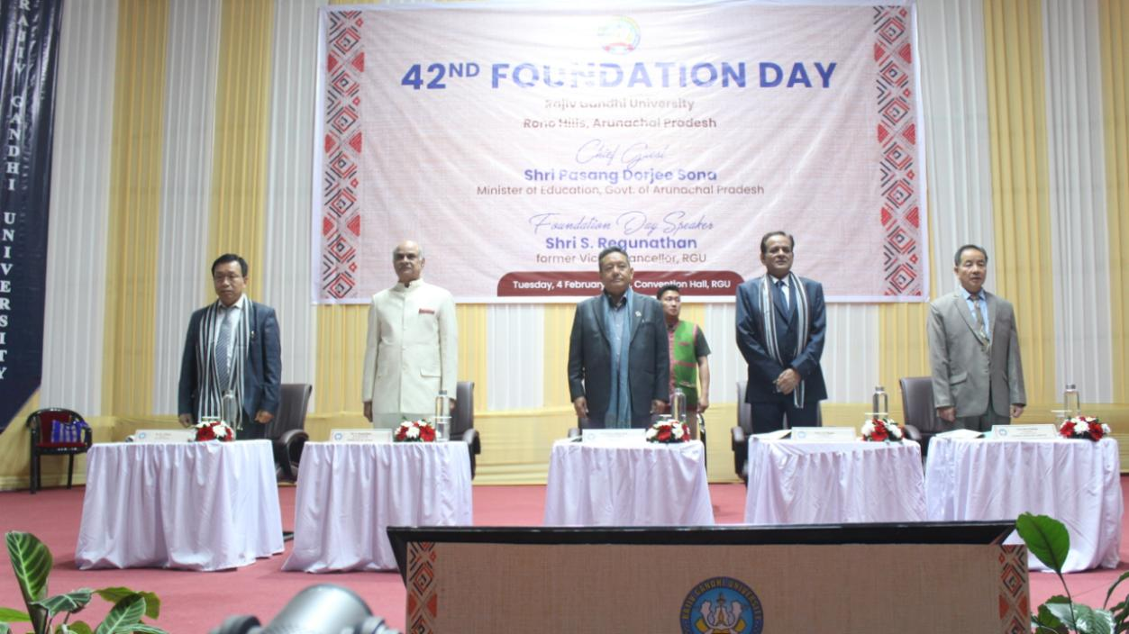

Rono Hills, February 4, 2025: The 42nd Foundation Day of Rajiv Gandhi University (RGU) was celebrated with great enthusiasm and a variety of activities at the RGU campus, marking the laying of its foundation stone on February 4, 1984, by the then Prime Minister of India. The formal event began with the inauguration of exhibition stalls showcasing products from local entrepreneurs and various university departments. The Chief Guest, Honourable Minister of Education, Government of Arunachal Pradesh, Shri Passang Dorjee Sona, inaugurated the function. Shri S. Regunathan, former Vice Chancellor of the university, was the Guest of Honour and delivered the 42nd Foundation Day lecture.
In his address to the gathering of faculty, staff, students, and community members at the convention hall, Shri Regunathan, who visited the campus after 33 years, shared his experiences from his time at the university. He praised the university for its growth, noting the introduction of new departments, courses, institutes, and infrastructure. He also acknowledged the university's role in the development of nearby localities, particularly the transformation of the Doimukh area. He emphasized that traditional bamboo homes should not be replaced by concrete structures, as these homes are an essential part of the state's identity. Furthermore, he urged students and scholars to stay connected to their roots and culture, highlighting the importance of giving back to society. He also stressed the need to harness the power of AI to help students adapt to changing times.
In his speech, Education Minister Shri Passang Dorjee Sona congratulated the university for its comprehensive development and national and international recognition. He discussed the importance of a holistic approach to education, where everyone is a stakeholder in driving change. He acknowledged that the foundation of the workforce in senior secondary and college education is weak, and thus, improving primary education would be a top priority. The minister also urged students, particularly university-goers, to be responsible and visionary in their use of social media. He pointed out that despite teachers being recruited through competitive exams, the quality of education in government schools remains lower than that of private schools. He stressed that the focus should be on quality over quantity and assured the public that the education system would improve with time.
Prof. S.K. Nayak, acting Vice Chancellor of the university, spoke about the state's progress in education, mentioning that when India gained independence, there were only two schools in the state. Today, the state has schools in every village, private colleges, technical institutes, and a renewed focus on education. He highlighted the state's gross enrolment ratio of 30%, which exceeds the national average, and reaffirmed RGU's commitment to academic excellence.
Dr. N. T. Rikam, Registrar of the university, delivered the welcome address and reflected on the university's journey, which began with just three departments and 48 students. Today, the university boasts over 40 departments and more than 5,300 students. He also celebrated RGU's achievement of A accreditation by NAAC in 2024 and commended the vital roles of faculty, staff, students, alumni, and community members in shaping the university's success. Prof. Otem Padung, Finance Officer and Chairman of the organizing committee, proposed the vote of thanks to all guests and participants.
As part of the celebrations, the university organized a photography and essay competition for students and employees. Mr. Sashakamoni Kashyap claimed first place in the photography competition, with Mr. Songio Tania and Ms. Priya Lomdak sharing second place, while Mr. Shashank Mishra took third. In the essay competition, themed ‘RGU of My Dreams: Milestones, Challenges, and Way Forward,’ Mr. Nima Dorjee emerged as the winner, with Ms. Ankita Hazarika and Mr. Tutumoni Borah taking second and third place, respectively.
The university also honored outgoing faculty, officers, and staff for their contributions in the past year. Prof. Bhagabat Nayak, Shri Kurian Thomas, Shri Tikendra Nath, Shri Sanjib Kumar Sur, Mr. Lalit Chandra Gogoi, and Shri Padma Bahadur Lama were recognized for their services. Additionally, the university launched an annual award series to recognize the best employees. Mr. Kanak Barman, Mr. Bake Karu, Mrs. Rupan Kalandi, Mrs. Tadar Monju, Mr. Raju Jomoh, Mr. Manik Das, and Mr. Shib Shankar Dutta were felicitated for their exceptional work.
Following the formal event, the university organized a sports competition and a cultural evening for students and employees. An exhibition was also held, where various departments showcased items such as books, ethnic food, traditional attire and accessories, fruits and vegetables, and other unique artisan products.
