GOVERNOR’S SECRETARIAT
ARUNACHAL PRADESH
ITANAGAR

Press Communiqué
Dated Feb 4th, 2025

Team AWAZ meets and interacts with Sikkim CM on their exposure tour

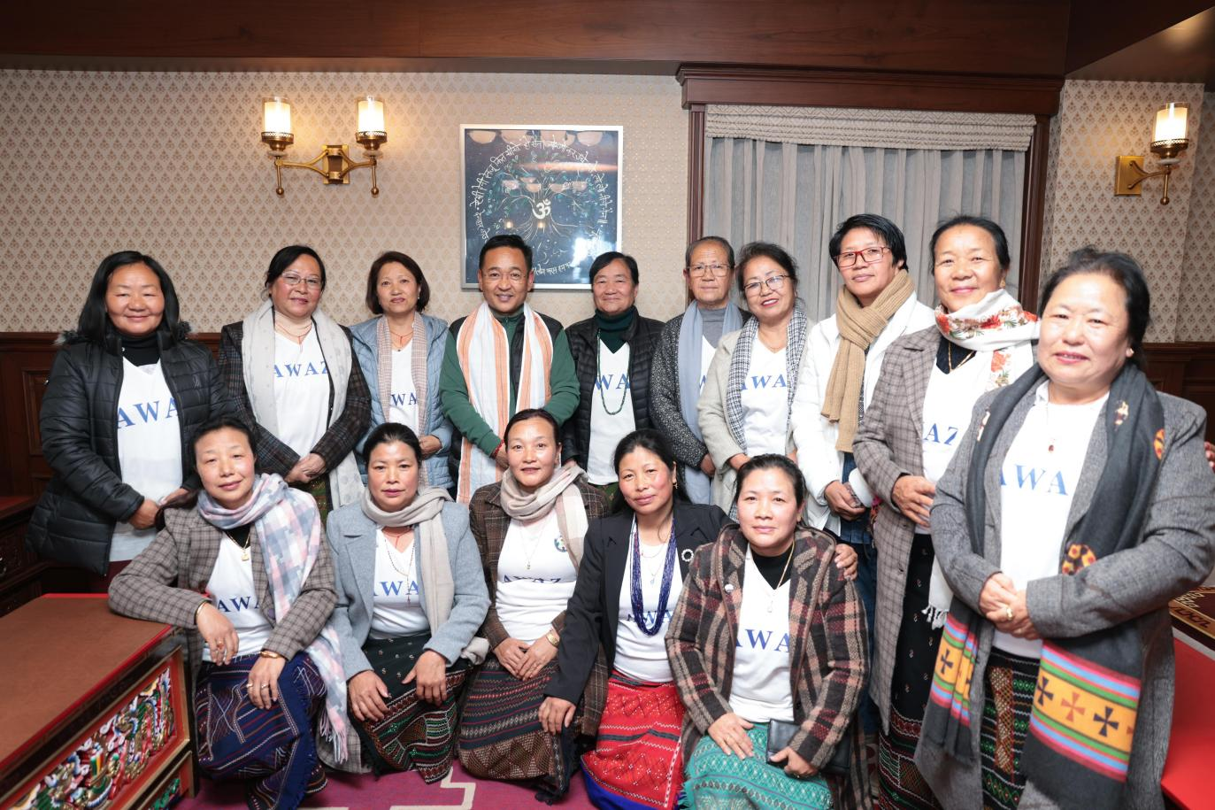

Ziro, 4th Feb 2025: A 14-member team of former executive members of the Apatani Women Association Ziro (AWAZ) embarked on a one-week exposure tour to Sikkim, culminating in an interaction with Sikkim Chief Minister Prem Singh Tamang Golay.
The all-women AWAZ team, which traveled from 28th January to 4th February, aimed to explore and study rural tourism facilities in Sikkim—one of India’s top tourist destinations—with the goal of implementing similar initiatives in Ziro, a well-known tourist hub in Arunachal Pradesh.
"Amidst the hustle and bustle of city life, there is an increasing appreciation for the slow, organic rhythm of village living," remarked former AWAZ president Hibu Lily. She emphasized that the team gained firsthand experience of Sikkim’s renowned rural eco-tourism facilities during the tour.
Detailing their journey, Lily shared that upon arriving in the remote village of Martam, East Sikkim, the team received a warm welcome from Ganesh Kr Chettry, the owner of Dhungay Homestay, which served as their residence for the week. "We instantly felt at home due to their exceptional hospitality. The homestay had a cozy and inviting atmosphere, with the entire family ensuring our stay was special," she added.
On 30th January, Ganesh led the team to an organic farm in a nearby village, where they observed traditional organic farming techniques practiced by Sikkimese farmers for sustainable land use. They also learned about mixed farming, which integrates crop cultivation with livestock domestication.
The following day, the team visited Barfung Retreat in South Sikkim and Khimzang Homestay in North Sikkim to gain deeper insights into the workings of rural homestays.
A highlight of the tour came on 2nd February, when the team was invited for dinner with Sikkim Chief Minister Prem Singh Tamang Golay. During this meeting, they engaged in meaningful discussions about women’s empowerment programs in both Arunachal Pradesh and Sikkim.
The Chief Minister introduced them to the Sikkim Aama Sashaktikaran Yojana (SASY), a flagship initiative providing ₹20,000 in financial aid to non-working, unwed, widowed, divorced, or separated mothers aged 18–59. This support enables women to invest in businesses or fund their children’s education. He also highlighted ‘Mero Rukh Mero Santati’, an innovative green initiative that strengthens the bond between parents, children, and nature by planting 108 trees for every newborn child in Sikkim.
Furthermore, he elaborated on various welfare programs, including the reservation policy for women in government jobs, NAMASTE Yojana, Bauhinia Scheme, and Vastly Scheme, which aim to uplift female manual laborers, provide free sanitary pads for schoolgirls, and offer financial security for girls through pension schemes covering education and marriage expenses.
During their interaction, Team AWAZ showcased their contributions to the community in education, sports, fashion, healthcare, and environmental conservation through cleanliness drives in Ziro Valley. They also highlighted the unique cultural traditions of the Apatani people, including paddy-cum-fish culture, kiwi farming, the entrepreneurial spirit of Naara Aba, and the renowned Ziro Festival of Music (ZFM)—India’s largest outdoor music festival. Additionally, they introduced the Sikkim CM to the vibrant Myoko and Dree festivals. Expressing keen interest, the Chief Minister shared his desire to visit Ziro Valley in the future.
Reflecting on the tour, former AWAZ general secretary Leegang Ania stated that it provided valuable insight into the proactive role of the Sikkim government in securing a better future for women and children. "We were delighted to learn that many government departments in Sikkim are led by women officials. AWAZ believes that true empowerment goes beyond financial aid—it requires providing women with equal opportunities and skill development," Ania remarked.
She extended heartfelt gratitude to the Hon’ble Chief Minister of Sikkim, Prem Singh Tamang Golay, for his warm hospitality, and to Ganesh Kr Chettry, the owner of Dhungay Homestay, for facilitating their meeting with the CM.
