GOVERNOR’S SECRETARIAT
ARUNACHAL PRADESH
ITANAGAR

Press Communiqué
Dated Feb 4th, 2025

NHPC Donates Life Saving Equipment to District Hospital Anini

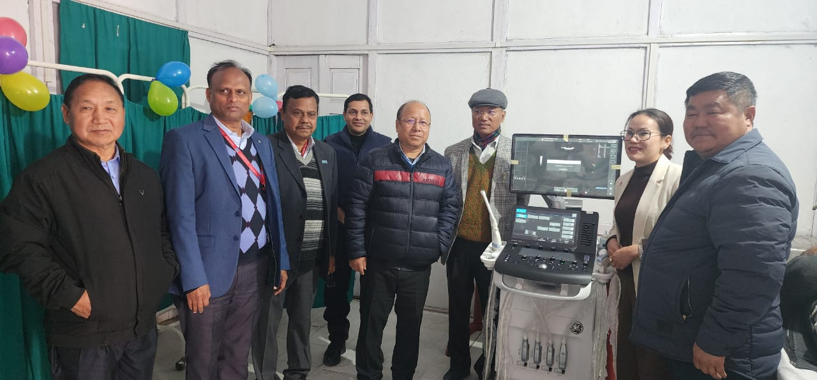
As part of its Corporate Social Responsibility (CSR) initiative, NHPC Ltd has donated an Ultrasound machine to the District Hospital, Anini, aiming to enhance healthcare services in the region. The handover ceremony took place in the presence of MLA Mopi Mihu, DC Pagli Sora, NHPC officials, DMO, MS DH Anini, and several department heads.
The introduction of the ultrasound machine will significantly reduce the burden on patients and pregnant women who previously had to travel 230 kilometers to the nearest town for such medical services. This facility will not only alleviate their hardships but also assist in the early detection of life-threatening diseases.
During the ceremony, HMLA congratulated the District Hospital for this life-changing achievement and encouraged NHPC Ltd to continue their philanthropic efforts. He emphasized the importance of effective utilization of the equipment and stressed the need for regular training sessions to keep hospital technicians updated with the latest advancements.
This is the second major contribution from NHPC in the district, following the construction of boys' and girls' hostels at the Government Residential School, Ranli under Arzoo Circle. NHPC Ltd is currently working on the Dibang Multipurpose Project in Dibang Valley and Lower Dibang Valley.
