GOVERNOR’S SECRETARIAT
ARUNACHAL PRADESH
ITANAGAR

Press Communiqué
Dated Feb 3rd, 2025

NCORD Committee Holds Monthly Review Meeting
in Upper Siang

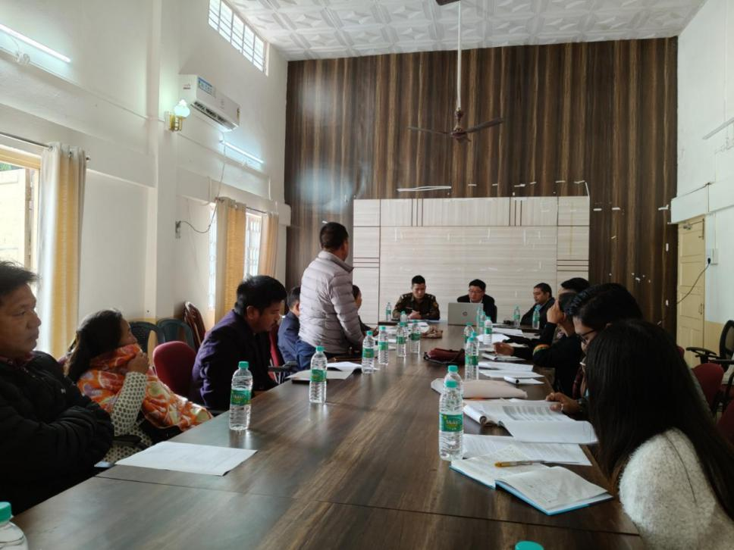

Yingkiong : A monthly review meeting of the District Narco Co-ordination ( NCORD) Committee held under the chairmanship of District Magistrate-cum-Chairman, District Level NCORD Committee, Upper Siang Sri Talo Jerang here at DC office conference hall, Yingkiong today on 3rd February’2025. The meeting was organized by the District Police in collaboration with District Administration, Upper Siang. During the meeting, minutes of last NCORD meeting were reviewed and follow up action initiated by all stakeholders were discussed.
While speaking to the members present in the meeting, DM Talo Jerang Said that ‘Drug addiction is not only an individual problem but it also affects the family and society at large and so we need concerted efforts from all sections of the society to make Upper Siang district drug free’. He said monthly review meeting of NCORD will held every first week of month to review and discuss new action plan. He added that ‘although there is no latest reports on Opium cultivation in the district but a continuous effort from Police, local administration, NGOs and civil society members must work together to discourage and totally eradicate opium cultivation thereby encouraging the farmers to adopt innovative sustainable farming activities for economic sustenance’. Underscoring the role of women groups in effective mobilization at community level , DC also asked the DD, ICDS to mobilise Aganwadi workers and helpers to spread awareness on anti-drug abuse campaign at village level through meetings and audio visuals to reach out to maximum numbers of people.
SP, Upper Siang Sri Token Saring also highlighted the activities taken up by District Police and informed that on phase wise manner currently police is focusing on three villages under Mariyang Sub division and accordingly constant vigilance and monitoring is being done by the police team. ADC Mariyang Sri N.Borang also spoke on use of creative arts to raise awareness on drug abuse, adding that art plays crucial role in voicing out inherent message. He also assured full support to police department from local administration side to fight against menace of drugs.
Meanwhile, DMO Dr. Gepeng Litin while informing the condition of District De addiction Centre, Yingkiong, pointed out need for separate centre for women for their convenience and safety. She also informed that CCTvs have been installed in all pharmacies and sale of unmonitored of syringes has been banned. DDSE Sri Duhon Tekseng also apprised the house that time to time anti-drug abuse campaign are carried out in schools to educate students and teachers. DD ICDS, Yingkiong Smti Ine Pertin informed that Aganwadi workers and helpers have instructed to carry out awareness program in their respective villages while DAO informed that awareness have been created among farmers to adopt alternative farming activities.

