GOVERNOR’S SECRETARIAT
ARUNACHAL PRADESH
ITANAGAR

Press Communiqué
Dated Feb 2nd, 2025

Infrastructure of Government Engineering College at Toru Near Completion; Cabinet Approval Awaited

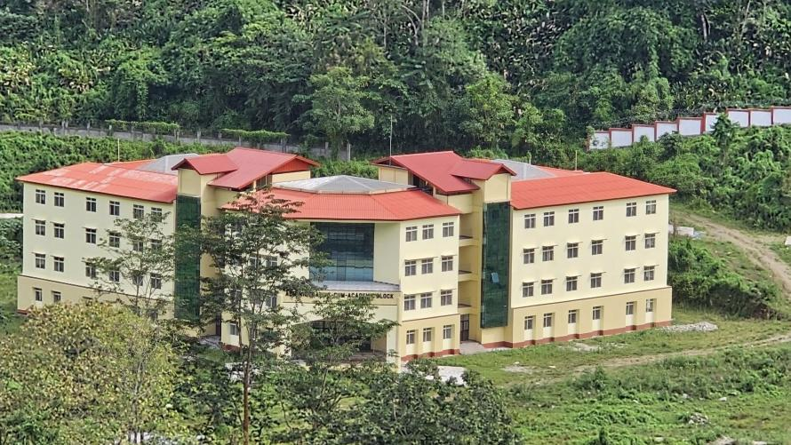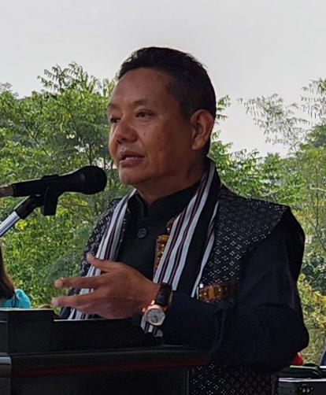

ITANAGAR, FEB 2 – The infrastructure of the Government Engineering College at Toru in Papum Pare district is nearing completion, according to Education and RWD Minister, P D Sona. Minister Sona, speaking to the media, confirmed that the manpower issue has been resolved by the AR department, and the proposal is now awaiting approval from the cabinet. "The faculty issue has been addressed and forwarded to the finance department for clearance. Once that process is complete, it will be presented to the cabinet. We hope to begin operations soon," said Minister Sona.
Additionally, the Government of Arunachal Pradesh has approved the establishment of the Government Science & Skill Development College at Tarasso, also located in Papum Pare district. This college will provide students with the opportunity to pursue higher education locally. A large plot of land for the institution has already been allocated, thanks to the efforts of the Nyishi Elite Society (NES) and its leadership.
"We are deeply committed to the reformation of the education system in Arunachal Pradesh. Our focus is not just on pass percentages but on delivering quality education. This will be achieved through a streamlined educational system, beginning with foundational education," the Education Minister emphasized.
Minister Sona also outlined plans for further educational reforms, including the formation of a medical board to review teacher transfers and postings across the state. A Project Management Unit (PMU) has been established to assess and improve educational infrastructure in four districts. This comprehensive review is expected to lead to the closure of some underperforming schools within the next four years, with the process extending to secondary and higher secondary schools. The government is consolidating and merging under-enrolled or defunct schools into centralized institutions to ensure efficiency and better allocation of resources. Minister Sona also emphasized the importance of safeguarding school properties against encroachment, citing the need for secure boundaries.
"We are determined to make our education system more reliable and vibrant, but this can only be achieved if all stakeholders come together to support these reforms," Sona concluded.
He further expressed his gratitude to the Papum Pare District Students Union (APPDSU) for their invaluable contribution in securing land allotments and LPCs for educational institutions in the district.
“We must move past the challenges of the past and focus on a brighter future for the education system in Arunachal Pradesh. Together, we can create a better and more secure future for our children,” the Education Minister said.
