GOVERNOR’S SECRETARIAT
ARUNACHAL PRADESH
ITANAGAR

Press Communiqué
Dated Feb 2nd, 2025

Conservation Volunteers Of The State Back With Renewed Zeal After Joining 76th Rd Celebration At New Delhi As Special Guests

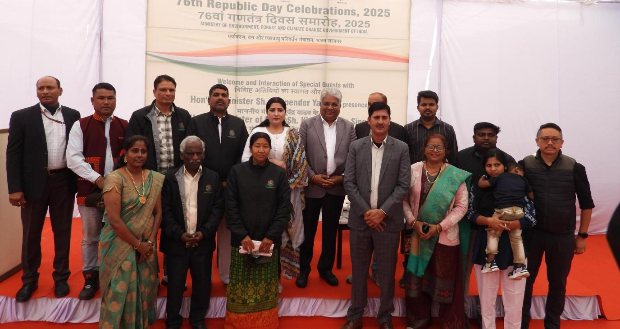

PASIGHAT / ITANAGAR Feb.02,: A team of forest and wildlife volunteers (eco volunteers ) are back to their green state with renewed zeal to carry on their conservation efforts in their respective areas gaining new insights , exposure to the nation’s rich history and governance after representing the state at the RD celebrations and exposure visits during the period. The recognition and representation of these dedicated individuals at the national level underscores the state government's efforts in forest and wildlife conservation.
In recognition of their tireless contributions to environmental forests and wildlife conservation in the state, a team of dedicated forest and wildlife conservation volunteers from Arunachal Pradesh was invited to witness this prestigious event of 76th RD celebrations at the national Capital.
It may be mentioned that Government of Arunachal Pradesh’s Forest and Environment Department represented by its conservation volunteers as special guests proudly represented the state at the 76th Republic Day celebrations held at Kartavya Path, New Delhi on 26th January last who also had an interaction programme with the Minister, E, F & CC, Govt. of India, Bhupender Yadav during their stay and visit. Accordingly, a five-member team comprising of volunteers and their spouses, namely Maksam Tayeng, Sonali Perme, Lobsang Tashi Thungon, Karma Chozom and Tenzing Norbu Thongdok, were nominated as special guests for the Republic Day celebration 2025, New Delhi in recognition of their dedication to forest and wildlife conservation by the office of the Principal Chief Conservator of Forests (WL & BD)-cum-Chief Wildlife Warden, Govt. of Arunachal Pradesh.
However, Tenzing Norbu Thongdok, Dy. FR, Poma Wildlife Range under Deputy Chief Wildlife Warden, Naharlagun and Lobsang Tashi Thungon, Member of Ghasung Thuk, a conservation group from Shegaon, West Kameng with his spouse Dr. Karma Chozom couldn’t participate in the event due to certain unavoidable reasons.

The team Arunachal Pradesh was represented by Maksam Tayeng, Chairman, Eco-Development Committee-cum-Community Surveillance & Monitoring Team from D. Ering Memorial Wildlife Sanctuary, Pasighat (who is also a journalist by profession giving special focus on forest and wildlife conservation and its challenges) along with his spouse Sonali Perme. Their selection as part of a distinguished group of 35 representatives from the Northeast highlights their vital role in fostering environmental sustainability under the vision of Swarnim Bharat (Golden India). The delegates from Arunachal Pradesh along with others from North Eastern states had the privilege of witnessing the grandeur of the Republic Day Parade, which showcased India’s military strength, cultural diversity, and technological achievements. They also explored iconic national landmarks, including the National War Memorial and the Prime Minister’s Museum (PM Sangrahalaya), gaining deeper insights into the nation’s rich history and governance.

On January 27, the team met with Mr. Bhupender Yadav, Union Minister for Environment, Forest & Climate Change, engaging in fruitful discussions on conservation strategies and environmental policies. The team Arunachal led by Maksam Tayeng also visited the office of the Ministry of Environment, Forests & Climate Change and met with the officials while discussing on the conservation challenges in the state.

Nyilyang Tam, Principal Chief Conservator of Forests (WL & BD)-cum-Chief Wildlife Warden, Government of Arunachal Pradesh was instrumental in nominating the individuals for this prestigious recognition. The recognition of these dedicated individuals at the national level underscores the state government's efforts in forest and wildlife conservation, the press note further informed.

