GOVERNOR’S SECRETARIAT
ARUNACHAL PRADESH
ITANAGAR

Press Communiqué
Dated Feb 2nd, 2025

33rd Dadamja Hoju Kuhwa Celebrated with Great Enthusiasm

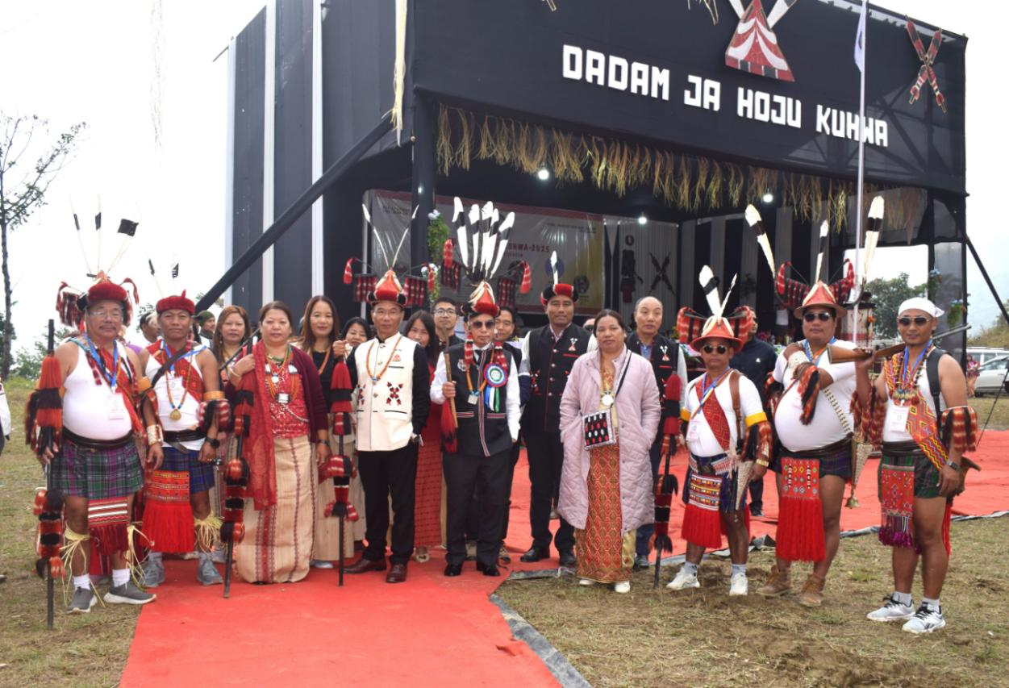

DADAM, 2nd February 2025: The vibrant celebration of the Dadamja Hoju Kuhwa festival took place with great enthusiasm at the Dadam circle headquarters on Sunday.
The Hon’ble Chief Guest, Wanglin Lowangdong, MLA of Borduria-Bogapani and Adviser to the HM-Environment & Forest, praised the people of Dadam for preserving their age-old traditions and cultural heritage. He highlighted the unity of the Nocte community, emphasizing that Hoju Kuhwa is a unique festival celebrated during the lean season, a time when people face difficulties due to a lack of livelihood opportunities. Reflecting on the historical ties between Dadam and Borduria, Lowangdong expressed his gratitude to the Dadamja Hoju Kuhwa Organizing Committee for inviting him as the Chief Guest and urged the youth of Dadam to follow in the footsteps of their forefathers, ensuring the continuity of their rich cultural traditions for future generations.
Chakat Aboh, MLA of Khonsa West and Adviser to the HM-Transport, who served as Chief Patron, encouraged the people of Dadam to remain united and continue their hard work for the welfare of their area and the Nocte community. She also thanked Lowangdong for accepting the invitation as the Chief Guest. Aboh emphasized that cultural festivals like Hoju Kuhwa and Chalo Loku should be celebrated without mixing in political differences, as culture fosters unity.
Tirap Deputy Commissioner Techu Aran, speaking as the Guest of Honour, commended the people of Dadam for maintaining their ancient traditions. He stressed that it is their responsibility, not that of outsiders, to preserve and promote their cultural heritage for future generations. He also used the opportunity to urge the people of Dadam and Tirap to stop hunting wild animals and birds, warning that such practices could harm the environment and upset ecological balance, ultimately affecting human life.
Wangroa Hakhun, President of the 33rd Dadamja Hoju Kuhwa Celebration Committee, spoke about the mythology and significance of the festival, which has been celebrated centrally at the headquarters in Dadam since 1992. He explained that the name Hoju Kuhwa comes from the words “Ho,” meaning the lean season, and “Ju,” meaning celebration, symbolizing a celebration during the challenging times of the agrarian calendar. While the festival is traditionally celebrated in various villages of Dadam during March and April, the Dadamja Hoju Kuhwa was first centralized under the Dadam Area Youth Association (DAYA) in 1992. The event was inaugurated by the then Education Minister, Dera Natung.
The day’s celebrations concluded with a vote of thanks from DJHKC 2025 Secretary, Shri Nyewang Lowang, who expressed his appreciation to Chief Guest Lowangdong and Deputy Commissioner Aran for attending the event despite their busy schedules.
The festival featured a range of traditional performances and activities, including:
- Offering of Rangtam (local wine) at the Chaam by the oldest man of Dadam village.
- Wentho-ram (Gun Blessings).
- A grand dance performance by women from the Dadam area.
- Traditional Hoju Kuhwa dances by villagers from Moktowa, Dadam, and Huakan.
- Modfern Nocte dance performances by girls from Hukan, Bera Girls, and the United Kothin Boys.
- The Wahphak-haapmin (Bamboo Stilt Walk Fight) competition among Dadam villagers.
The event was attended by a range of dignitaries, including Special Guest SP Tirap Singjatla Singpho, ADC H/Qs Tana Bapu, CO 36Bn CRPF Lamkhokam Lhoujem, ZPM Khonsa Block Shri Wanghong Panka, Chairperson of the Nocte Women’s Association Smti Chasuam Wangchadong, CO Borduria Yowa Anya, CO Dadam Dr. Metung Taku, along with government officers, panchayat leaders, GBs, OC PS Dadam, and Assam Rifles personnel.
