GOVERNOR’S SECRETARIAT
ARUNACHAL PRADESH
ITANAGAR

Press Communiqué
Dated Feb 28th, 2025

Inauguration of NWA office
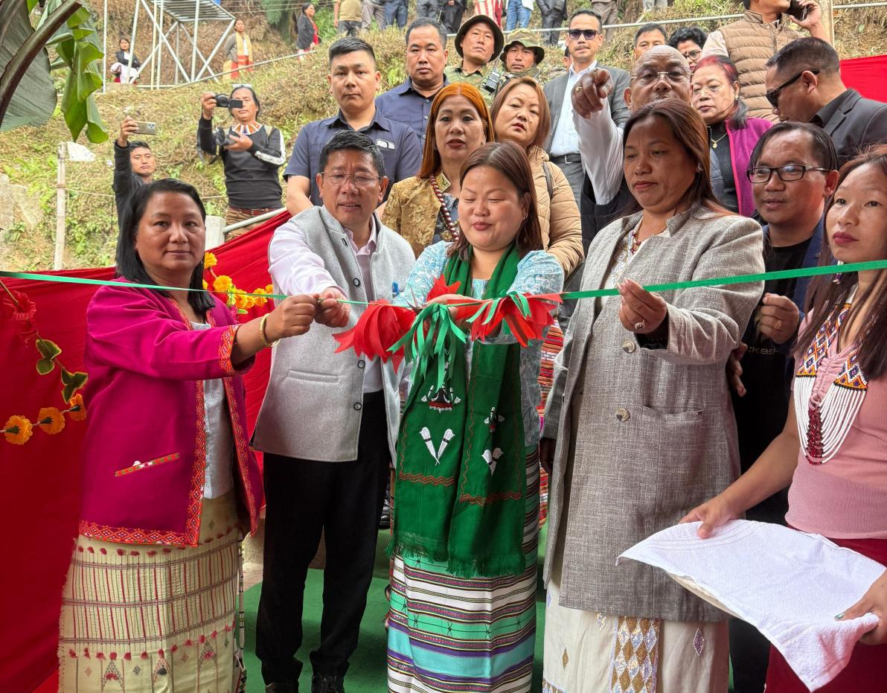

Khonsa: Women & Child Development minister Dasanglu Pul on Friday inaugurated the office of the Nocte Women Association (NWA) and the Arunachal Indigenous & Heritage Centre in Khonsa, Tirap district, calling it a significant step towards women’s empowerment and the preservation of indigenous heritage.
Addressing the gathering, Pul underscored the importance of strengthening women's voices and safeguarding traditional culture.
"Women play a crucial role in shaping society and such initiatives will empower them while also preserving our rich indigenous heritage," she said.
Pul lauded the Nocte Women Association for its efforts in advocating women's welfare and fostering social progress.
"This initiative will open new avenues for socio-economic upliftment, ensuring greater participation of women in development activities," she said.
The Arunachal Indigenous & Heritage Centre, on the other hand, aims to serve as a hub for promoting and protecting the diverse cultural traditions of the state's tribal communities.
Pul said the centre would facilitate research, documentation, and awareness programmes to sustain indigenous practices and heritage.
She further expressed optimism that the newly inaugurated centres would serve as platforms for cultural preservation and community-driven initiatives aimed at holistic growth in the region.
The event was attended by MLAs Chakat Aboh, Nyabi Jini Dirchi, and Wanglam Sawin, along with Nocte Women Association chairperson Chasuam Wangchadong, Tirap deputy commissioner Techu Aran, superintendent of police Singjatla Singpho and other officials.
