GOVERNOR’S SECRETARIAT
ARUNACHAL PRADESH
ITANAGAR

Press Communiqué
Dated Feb 28th, 2025

Joint Consultative Meeting Focuses on De-reservation and Rationalization of Drupang Reserve Forest and Itanagar Wildlife Sanctuary
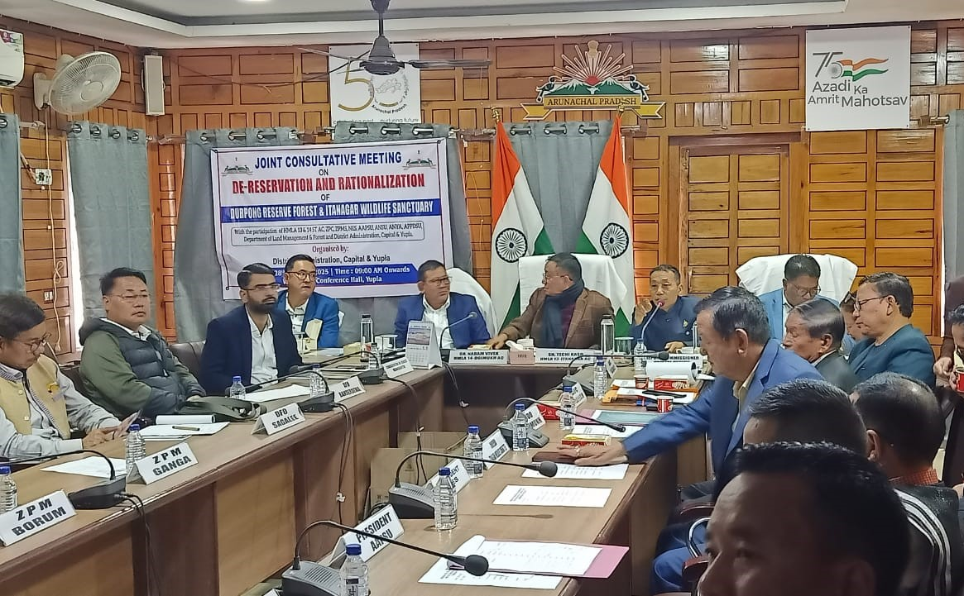

Yupia, 28th February,2025 : 13 Itanagar MLA Techi Kaso suggested for conducting consultative meetings amongst the actually affected people of the villages before finalization of the de-reservation and rationalization proposal for Drupang Reserve Forest and Itanagar Wildlife Sanctuary, during a joint consultative meeting of HMLAs , DCs, admin officers, Forest and land Officials of Papum Pare, representatives from NES, ANSU, ANYA, APPDSU and Aboriginal Tribal Inhabitant Villagers of Itanagar Capital Region, Panchayat leaders and officials of the land department held in the DC Conference Hall, Yupia today.
The meeting was held to discuss the roadmap for de-reservation and rationalization proposal for Drupang Reserve Forest and Itanagar Wildlife Sanctuary.
“By engaging with affected villagers and studying the ground reality, the committee can ensure that the voices of local communities are heard and considered in the decision-making process leading to a more comprehensive understanding of the proposal's impact.” Kaso added.
14-Doimukh MLA Nabam Vivek while speaking during the meeting advocated for forming local committees at the ADC level to understand the ground realities and modulate plans that are sustainable.
He also emphasized on seeking public consent and opinion before finalizing the draft for de-reservation, ensuring that the voices of local communities are heard and considered.
DC, ICC Talo Potom while presenting a brief on the draft proposal spoke about the need for rationalization and de-reservation.
“The need for diversion of forest land to non-forest purpose; addressing the resentment of the natives villagers and establishing their rights; regularizing the already constructed govt. infrastructures and public settlements; catering to the growing population and to define clear boundaries for ecological restoration have necessitated the de-reservation,” he informed.
He further highlighted the contents of draft proposal which included the areas and villages proposed for rationalization; which however was opposed by the members of Aboriginal Tribal Inhabitant Villagers of Itanagar Capital Region(ATIVICR ) sating that the "The proposal to rationalize the Itanagar Wildlife Sanctuary in their ancestral land by the state government will never be accepted”.
Shri Nera Techi, General Secretary, (ATIVICR) however suggested that “ Out of the 140.8 sqkm of the notified Itanagar Wildlife Sanctuary 66 sq.Km constituting the upper ridge areas can be considered for rationalization.”
Techi Toka, Chairman of ATIVICR, also expressed dissatisfaction at the inclusion of the Itanagar Capital Region (ICR) and several other villages within the boundaries of the wildlife sanctuary.
Shri Manish Kumar Jha, DyDCF while assuring co-operation requested the local committees formed for the purpose to have consultations with the affected people to work out an amicable solution.
Shri Gamru Ruja, President ANYA, Mai Arun Camdir, President ANSU, APPDSU President Gollo Lento , representatives from NES, forest officials also spoke and voiced the need to be empathetic to land donors and other affected people.
The other points discussed during the meeting included protecting the catchment areas to prevent environmental degradation and ensure sustainable development, the requirement of a strong political will to drive the de-reservation and rationalization process forward , the need for identifying alternate land for de-reservation, ensuring minimal environmental impact, cooperation among all stakeholders, including government officials, local communities, and civil society organizations.
The joint consultative meeting concluded with a consensus on the need for a collaborative approach to address the complex issues surrounding the de-reservation and rationalization of Drupang Reserve Forest and Itanagar Wildlife Sanctuary by consultation with all stakeholders, to ensure that the de-reservation and rationalization process is transparent, inclusive, and environmentally sustainable.

