GOVERNOR’S SECRETARIAT
ARUNACHAL PRADESH
ITANAGAR

Press Communiqué
Dated Feb 28th, 2025

4th State level “ Run for Unity “ Marathon organized at Pasighat
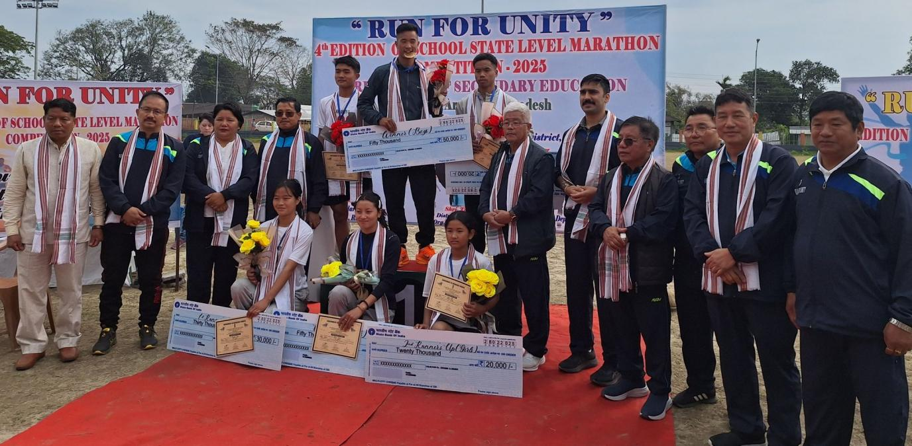

PASIGHAT, Feb28 : The fourth edition of the annual school State level event on theme of “ Run for Unity “ Marathon Race Competition, participated by young talented athletes from various schools of the State, was organized today with enthusiastic participation by young school athletes - with an 18 KM Mini Marathon Run flagged off from GHSS Mebo ( Romdum) and culminating at DEM,GHSS. Around eighty Athletes from various schools of eleven districts participated in the Marathon Race, organized by the Department of Education, East Siang under the aegis of Directorate of Secondary Education, GoAP.
The event was attended by DC East Siang,Tayi Taggu, SP, Pankaj Lamba, Director of Secondary Education, GoAP, Marken Kadu,ZPC Olen Rome, Chief Councillor, Okiam Moyong Borang,
Jt.DHS Dr. T.Tali , DDSE Odhuk Tabing , Principal IGJGHSS , Pasighat O.Tabing, District Sports Coordinator & Organising Secretary 4th Edition “ Run for Unity”, Tanya Padung among others.
The dignitaries gave away the prizes to the winners comprising of Trophy, Certificates and Cash Prizes of Rs. Fifty thousand for winner, Rs. Thirty thousand and Twenty thousand for the second and third runners up.
In the Boys category, Agalumso Tawsik from Lohit district clinched the gold medal with Taba Jobang representing Papumpare district & Phongam Wangpan of Longding District taking the Silver & Bronze Medals respectively.
In the Girls Category, Miss Yanu Mane from Shi-Yomi and Miss Yanam Ruku also from Shi-Yomi and Yaris Goi ( East Siang district) reached the finishing line at the second and third places respectively.
DC East Siang in his speech encouraged the youth and students to make games and sports integral part of their life , as he stressed on the power of Games and Sports in promoting a healthy body and mind and promoting leadership and team spirit.
The DC also urged the young athletes to be changemakers and keep away from drugs and addictive substances adding that sports can also open various avenues for them in life.
Director, Secondary Education Marken Kadu also spoke on the scopes for meritorious sportspersons and the objectives for organizing the event.
DDSE Odhuk Tabing also spoke on the occasion.
The event is also aimed to promote national integration and unity and solidarity and celebrate the spirit of unity in diversity of the country and also to nurture young talents from schools of various districts .

