GOVERNOR’S SECRETARIAT
ARUNACHAL PRADESH
ITANAGAR

Press Communiqué
Dated Feb 26th, 2025

Illegal Tobacco and Substance Seized and Disposed; Over 35 Shops Fined for Violating COTPA Act
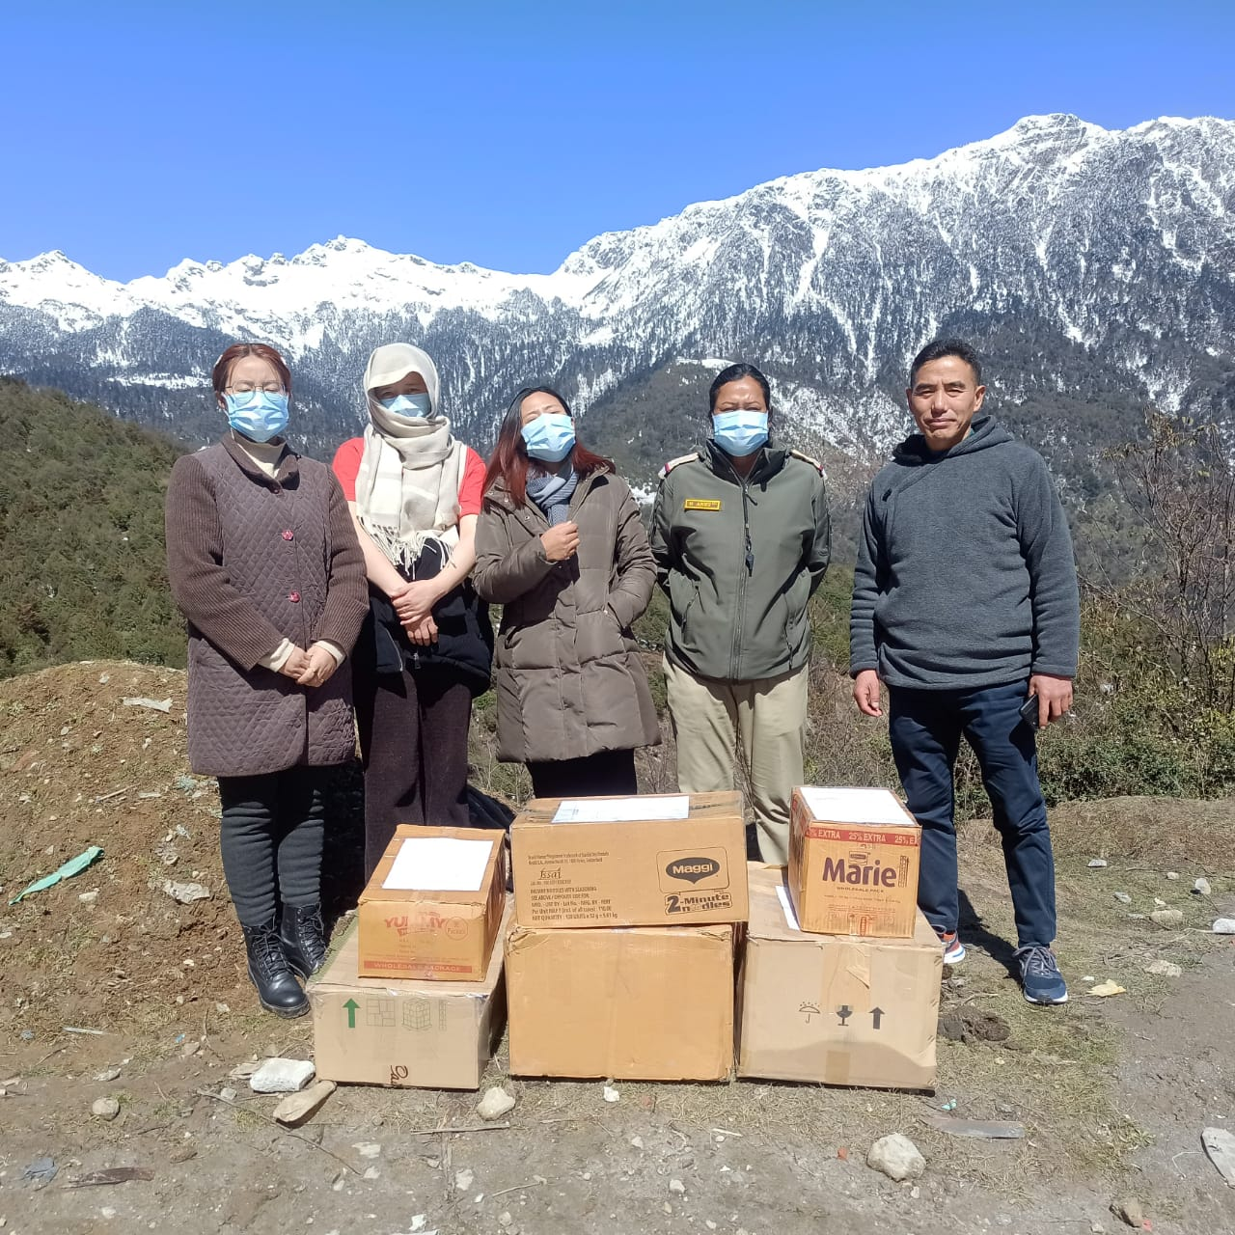

Tawang, 26/02/2025: The District Enforcement Squad, under the National Tobacco Control Programme (NTCP) and the District Level Coordination Committee, conducted a surprise raid in the township from 21st February 2025 onwards to ensure compliance with the Cigarettes and Other Tobacco Products Act (COTPA) 2003, specifically Sub-Section 6(b).
As a result of the operation, more than 35 shops were penalized for violating the Act. The shop owners were also made aware of the provisions of COTPA 2003 and the harmful effects of tobacco and substance abuse. Such raids are conducted quarterly across the district to curb illegal tobacco sales and raise awareness about public health concerns.
On 26th February 2025, the seized and sealed items, including cigarettes, hand-rolling tobacco, chewing tobacco, and other abusive substances, were officially disposed of at the designated dumpsite near Changbu. The disposal process was carried out in the presence of Sangey Norbu, Town Magistrate, along with police officers and officials from the District Tobacco Control Cell.
The district administration,Tawang has urged all vendors and citizens from time to time through various official communications to abide by the COTPA Act and contribute towards a tobacco-free environment. The authorities remain committed to strict enforcement of the law and will continue their efforts to protect public health through regular inspections and awareness campaigns.
