GOVERNOR’S SECRETARIAT
ARUNACHAL PRADESH
ITANAGAR

Press Communiqué
Dated Feb 26th, 2025

Deputy Chief Minister Attends Silver Jubilee Nyokum Yullo Celebration in Yangte, Kra Daadi
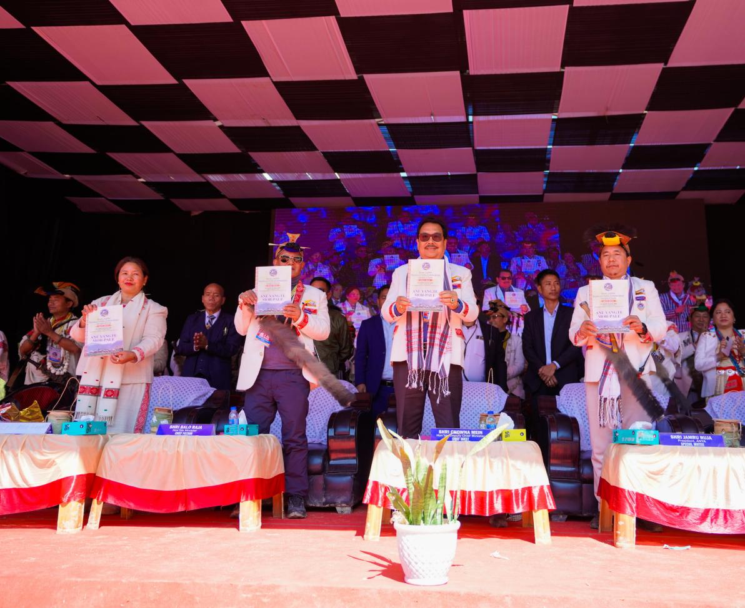

YANGTE, February 26: Deputy Chief Minister Chowna Mein attended the Silver Jubilee Nyokum Yullo Celebration in Yangte today, commemorating 25 years of Central Nyokum Yullo Celebration in Yangte Circle under Kraa Dadi District. The event was a vibrant reflection of age-old traditions, fostering unity and pride among the people.

Extending congratulations to the people of Yangte, the Deputy Chief Minister emphasized the significance of preserving their cultural identity. He stated, “Nyokum Yullo is more than a festival; it is a living legacy, an ancestral treasure passed down through generations. It reminds us of the importance of safeguarding our heritage, which defines who we are”.
“As Arunachalees, we must continue to take immense pride in our roots, for they embody the spirit of being Arunachalee,” he added.
Reaffirming the government’s commitment to promote tribal local language, customs, and traditions, he assured continued support for the preservation and promotion of our rich cultural heritage for generation to thrives.
He assured to sanction fund for the construction of a cultural podium and open hall at Nyokum Yullo Ground in Yangte.
On the occasion, DCM released a festival souvenir titled ‘Ane Yangte Mor-Pale’, published by the celebration committee commemorating the Silver Jubilee Nyokum Yullo Celebration in Yangte Circle.
The event witnessed the presence of several distinguished guests, including Minister of Urban Development Affairs, Land Management and Civil Aviation, Balo Raja, DC Kraa Dadi, Charu Nili, ZPC Charu Menia, among others.

