GOVERNOR’S SECRETARIAT
ARUNACHAL PRADESH
ITANAGAR

Press Communiqué

Dated Feb 25th, 2025

Governor accentuates State’s investment avenues in ET Business Conclave
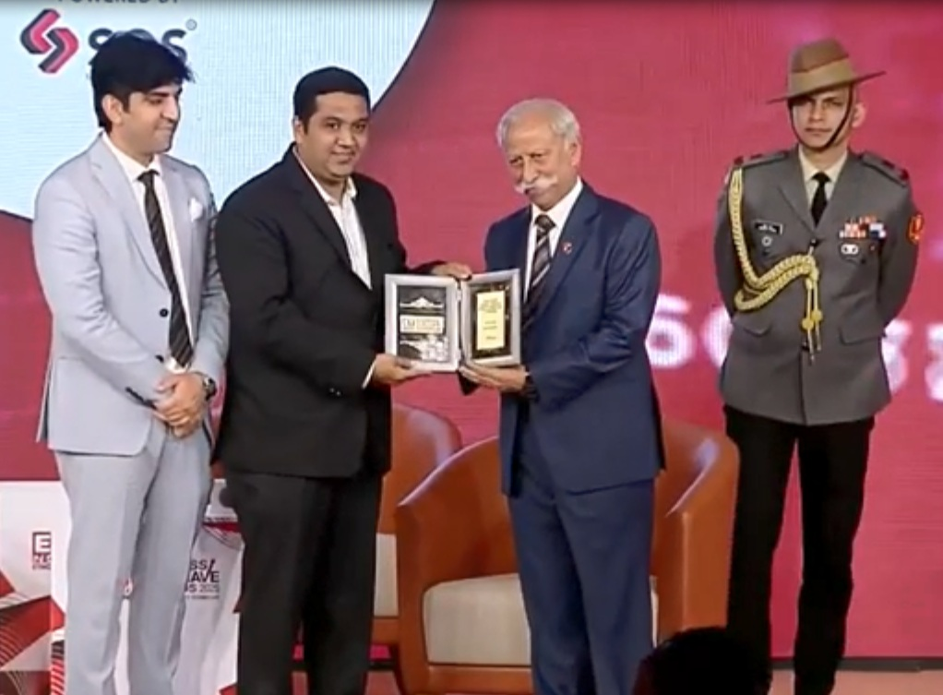

The Governor of Arunachal Pradesh, Lt. General K.T. Parnaik, PVSM, UYSM, YSM (Retd.), participated in the prestigious ET Now Business Conclave & Awards 2025 in New Delhi on 25th February 2025. The event brought together visionary leaders, policymakers, and industry experts to discuss India's transformative growth journey, focusing on data-driven insights, strategic planning, and innovative solutions for inclusive economic development aligned with India @2030.
Addressing the gathering, the Governor highlighted the ease-of-doing-business initiatives undertaken by the Arunachal Pradesh Government. He outlined investment opportunities in the state and emphasized its unique advantages for businesses.
The Governor said that Arunachal Pradesh remains the only State in the region unaffected by terrorism, enabling aggressive developmental initiatives. He highlighted key infrastructure advancements, including the expansion of road networks to the First Villages and the provision of 4G connectivity. State also produces largest quantity of Kiwi in India, which is planned to be exported. He emphasized the strong nationalistic spirit of the people and the widespread use of Hindi and English, facilitating seamless communication for businesses.
Speaking on the State’s tourism potential, the Governor described Arunachal Pradesh as a land of unparalleled natural beauty, making tourism one of its core economic drivers. He highlighted the diverse tourism opportunities, including eco-tourism, religious tourism, and adventure tourism, positioning the sector as a vibrant avenue for entrepreneurship and partnerships.
Discussing the State’s hydropower potential, the Governor stated that Arunachal Pradesh has a capacity of 58,000 MW, nearly 40% of India's total hydropower potential. Several projects are operational or under construction, including the Dibang Multipurpose Hydro Project (2880 MW), one of India's largest. Once fully commissioned, these projects are expected to generate over ₹10,000 crore in annual revenue.
The Governor praised the tribal communities for their commitment to environmental conservation, underscoring Arunachal Pradesh’s status as a Green State. He shared government initiatives that balance development with sustainability, including streamlined land acquisition policies and a single-window clearance system for businesses.
As an ‘enabler Governor’, the Governor reaffirmed his commitment to advising the State Cabinet and senior bureaucrats on policies that enhance the well-being and welfare of the people. He assured business leaders that Arunachal Pradesh offers vast opportunities for investment and collaboration.
On this special occasion, the Governor also presented awards to distinguished business leaders and organizations for their excellence in leadership and outstanding contributions across various sectors, including education.
