GOVERNOR’S SECRETARIAT
ARUNACHAL PRADESH
ITANAGAR

Press Communiqué

Dated Feb 21st, 2025

Governor confers State Awards, Chief Minister’s Award for Excellence in Public Administration
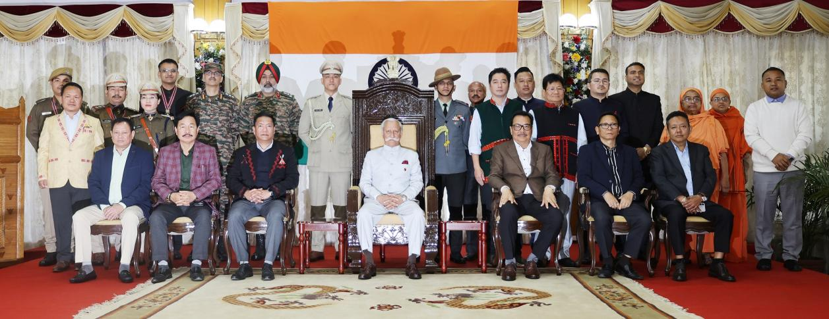

The Governor of Arunachal Pradesh Lt General KT Parnaik, PVSM, UYSM, YSM (Retd) conferred the State Gold and Silver Medals to organizations of the State and meritorious persons for their outstanding merit and exceptional bravery, in the Durbar Hall, Raj Bhavan, Itanagar on February 21, 2025. The Governor also conferred the Chief Minister’s Award for Excellence in Public Administration and felicitated the medal winners of the 38th National Games – 2025, Uttarakhand.
State Gold Medals were conferred to seven organizations and three individuals. Donyi Polo Mission School for the Hearing and Visually Impaired, Chimpu, the Department of Cardiology, Tomo Riba Institute of Health and Medical Sciences, Naharlagun, Women Police Station, Itanagar, Project Vartak under Border Roads Organization, Donyi Polo Cultural & Charitable Trust, Itanagar, Ramakrishna Sarada Mission, Khonsa and the Centre for Bear Rehabilitation & Conservation, Pakke Tiger Reserve, Seijosa were awarded the State Gold medal. Shri Anant Mittal, IPS, Superintendent of Police, Anti-Corruption Bureau, Shri Minli Geyi, Inspector, Officer-In-Charge of Police Station, Seppa and Shri Jimkam Khomrang, Constable, Police Station, Seppa received the State Gold Medal.
In recognition of their dedicated services towards the welfare and progress of the State, Shri Jambey Dorjee Dunglen, Farmer, Salari, West Kameng District, Shri Togum Gongo, APPS, Deputy Superintendent of Police, Khonsa, Shri Tapan Datta, DFDO, Shi- Yomi District, Mrs. Jyoti Panka, PGT, PM Shri Govt. Higher Secondary School, Londging, Shri Mato Bage, Deputy Forest Ranger, Shergaon Forest Division, West Kameng District, Shri George Pajing, AAPDA Mitra Volunteer, Pasighat, East Siang District, Shri Rishi Longdo, APPS, Deputy Superintendent of Police, Kurung Kumey District, Ms. Neha Yadav, IPS, Principal, PTC, Banderdewa, Shri Chau Woipeng Manpoong, Circle Officer, Kurung Kumey District, Shri Sudhanshu Dhama, IPS, Superintendent of Police, Bomdila, Smt. Moyir Basar Kamdak, Deputy Superintendent of Police, SDRF, Chimpu, Shri Kushal Bhander Kaystha, Entomologist, Tawang and Dr. Tashi Phuntso, in-charge Principal, Govt. College, Bomdila, West Kameng District were conferred with State Silver Medals.
The Governor conferred the Chief Minister’s Award for Excellence in Public Administration to two offices and the Department of Agriculture for the year 2024. The award was conferred to the Office of the Superintendent of Police, Itanagar for the exemplary work ‘e-Services: Transforming Public Service Delivery in Arunachal Pradesh’, which made the public delivery systems responsive, transparent and efficient, particularly by leveraging technology, while the office of the Deputy Commissioner, Papum-Pare District received the award in recognition of the exemplary work in ‘Innovation Lab Project Creative Catalyst & Speak SMART East, which facilitated in implementation of innovative ideas, schemes, projects to meet stakeholder's requirement. The Department of Agriculture received the prestigious Chief Minister's Award for ‘Championing of Shree Anna (Millets) initiatives for the success of International Year of Millets 2023 (Mission mode implementation of schemes prioritized by the State Government including those announced in the Budget’ and for the exemplary work in ‘CPO Mill establishment in Arunachal Pradesh (Mission Mode implementation of Government of India schemes including specific categories/themes mentioned in the Prime Minister's Awards for Excellence in Public Administration for the years)’. The award, which includes a cash prize of Rs. 10 Lakhs and an honorary Scroll, acknowledges your team's tireless efforts and commitment to excellence in public service.
The Governor presented the certificate of excellence to Sportspersons in recognition of their exemplary contribution towards sports in various events in the 38th National Games – 2025, Uttarakhand. Miss Khinsan Wangsu - Gold Medal (Taekwondo - Poomsae), Miss Rikpy Nyodu - Gold Medal (Taekwondo - Poomsae), Miss Achum Sanga - Gold Medal (Taekwondo – Poomsae Female Group), Miss Radha Bangsia - Gold Medal (Taekwondo – Poomsae Female Group), Miss Lumter Uli - Gold Medal (Taekwondo – Poomsae Female Group), Miss Mercy Ngaimong - Gold Medal (Wushu - Jiansu), Miss Nyeman Wangsu - Gold Medal (Wushu - Daoshu), Shri Miching Taja - Silver Medal (Taekwondo – Poomsae Mixed-Pair), Shri Markio Tario -Silver Medal (67 Kg Weight Lifting), Miss Chera Loku - Silver Medal (Wushu - Taijiquan), Ms. Devi Dada - Bronze Medal (Kayak Cross), Shri Kamdon Boi - Bronze Medal (Judo), Shri Akash Kumar Ram - Bronze Medal (Taekwondo – Poomsae Male Group), Shri Kame Bagang - Bronze Medal (Taekwondo – Poomsae Male Group), Miss Balo Yalam - Bronze Medal (59 Kg Weight Lifting), Miss Yorna Roshni - Bronze Medal (Wushu - Nandao) and Miss Gyamar Yatup - Bronze Medal (Wushu – 48kg Taolu) received the letter of appreciation.
State Chief Minister Shri Pema Khandu, Deputy Chief Minister Shri Chowna Mein, ministers, Member of Parliament (Lok Sabha) Shri Tapir Gao, MLAs, senior government officers and special invitees were present on the occasion amongst other dignitaries and awardees. State Chief Secretary Shri Manish Gupta conducted the award ceremony.
On the special occasion, the Governor and the Chief Minister interacted with the award winners and distinguished guests over a High Tea in the General Bipin Rawat Hall, Raj Bhavan, Itanagar.
