GOVERNOR’S SECRETARIAT
ARUNACHAL PRADESH
ITANAGAR

Press Communiqué

Dated Feb 20th, 2025

Hon’ble Governor Lt. General KT Parnaik’s Address on Arunachal Pradesh’s 39th Statehood Day
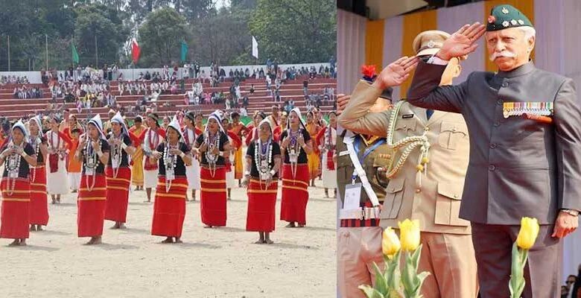
Itanagar, February 20, 2025: On the occasion of Arunachal Pradesh's 39th Statehood Day, Hon’ble Governor Lt. General KT Parnaik, PVSM, UYSM, YSM (Retd.) extended his warm greetings and best wishes to the people of the state. Speaking at a large gathering at Indira Gandhi Park in Itanagar, the Governor reflected on Arunachal Pradesh's exceptional journey, celebrating its unique cultural heritage, socio-economic advancements, and significant contributions to national unity. He called for united efforts to realize the vision of a strong, self-reliant, and developed Arunachal Pradesh.

Celebrating Arunachal Pradesh’s Cultural and Historical Richness
The Governor began his speech by recognizing the state's rich cultural diversity, home to 26 major tribes and over 100 sub-tribes, each adding to the vibrant fabric of Arunachal Pradesh. He praised the traditional wisdom, values, and resilience of the people, who have consistently upheld national integrity.
Hon’ble Governor also honored freedom fighters and unsung heroes of Arunachal Pradesh, including Matmur Jamoh, Moje Riba, and others, whose contributions were pivotal in preserving the state’s identity. Their sacrifices continue to inspire the people to work towards the state's growth and prosperity.
Development Achievements and Government Initiatives
The Governor highlighted the significant progress achieved under the leadership of the Government of India, specifically in the following sectors:
Infrastructure and Connectivity
  - Over 4,000 km of roads constructed in the last eight years, enhancing connectivity to remote areas.
  - Priority development of the Frontier Highway (1,748 km) and Trans-Arunachal Highway (1,550 km), strengthening the strategic and economic outlook of the state.
  - The operationalization of Hollongi Greenfield Airport, improving air connectivity and promoting tourism.
  - Expansion of the railway network, including routes such as Bhalukpong-Tawang and Murkongselek-Pasighat.

Hydropower Development
  - Arunachal Pradesh’s vast hydropower potential (over 57,000 MW) has led to accelerated development of major projects like:
    - Lower Subansiri Hydroelectric Project (2,000 MW)
    - Dibang Multipurpose Project (2,880 MW)
  - These projects are set to generate over ₹10,000 crore annually, transforming Arunachal into a power surplus state and significantly boosting the economy.
Education and Youth Empowerment
  - Establishment of 30 new Higher Secondary Schools and 10 Eklavya Model Residential Schools (EMRS) to provide quality education to tribal students.
  - Vocational and skill development programs under the Skill India Mission, making thousands of youth job-ready.
  - Hon’ble Governor declared 2025 as the ‘Year of the Youth,’ with a focus on employment, entrepreneurship, and leadership training.
Women’s Empowerment and Rural Development
  - The ‘Lakhpati Didi’ initiative benefiting 4,332 women entrepreneurs, with a target of 25,000 women earning over ₹1 lakh annually by 2026.
  - Empowering women through Self-Help Groups (SHGs), providing financial and business opportunities in agriculture, weaving, and handicrafts.
  - Growth in women-led initiatives in organic farming, food processing, and tourism, contributing to economic self-sufficiency.
Challenges and the Path Forward
Despite these successes, the Governor acknowledged key challenges that need attention to ensure sustainable and inclusive growth. These include:
Education and Skill Development
  - Addressing school dropout rates, particularly in remote areas, through scholarships and digital learning initiatives.
  - Strengthening higher education institutions to attract students from across the Northeast.
Combating Drug Abuse and Promoting Youth Welfare
  - The state government is taking action through rehabilitation, de-addiction programs, and strict measures against drug trafficking, along with awareness campaigns in schools and communities.
Environmental Sustainability
  - Focusing on proper waste management and promoting eco-friendly practices across urban and rural regions.
  - Encouraging community-driven cleanliness drives under the Swachh Bharat Mission.
Technology-Driven Governance
  - Enhancing e-Governance systems to improve transparency and administrative efficiency.
  - Implementing real-time monitoring systems for infrastructure projects.

Tourism and Sustainable Development
  - Leveraging Arunachal Pradesh’s natural beauty and biodiversity to develop eco-tourism hubs, adventure circuits, and homestay networks, which will provide employment and uplift local businesses.
  - Investment in hospitality training programs to improve service standards in tourism.
A Call for Unity and Collective Action
In his concluding remarks, Hon’ble Governor Lt. General KT Parnaik urged all citizens, government officials, and stakeholders to work collaboratively in building a self-reliant, prosperous Arunachal Pradesh.
“The future of Arunachal Pradesh lies in our collective efforts. Each of us has a role in shaping a ‘Viksit Arunachal’ that is progressive, inclusive, and self-sustaining. Let us unite, innovate, and pursue excellence.”
The Governor reaffirmed his commitment to serving the people of Arunachal Pradesh and wished everyone a joyous and prosperous Statehood Day.
Jai Arunachal! Jai Hind!

